### Lab 1. Map-making in ArcGIS

### Introduction

### This lab will introduce ESRI’s ArcGIS 10.2 software including the ArcMap and ArcCatalog applications.

### Instructions

Based on the assigned readings for this week, answer questions in Part I of this lab.  Then proceed to the next Parts and complete the hands-on exercises.  Before working with the lab data, copy it from the shared Dropbox folder onto your flash drive.

### Deliverables

Answer the following questions and produce the required outputs. Your lab document should be typed, well organized, and submitted based on the “How To” guidelines provided in the course syllabus.

**PART I – Assigned Readings**

*Textbook – Bolstad (Chap. 1)*

1. What is a geographic information system? (Put it into your own words - do not give me the quoted definition in the text or lecture notes.)
2. List the five main categories of functions commonly provided by GIS software.
3. What are the limitations of using a GIS? Under what conditions might the technology hinder problem solving, rather than help?
4. What is Geographic Information Science (GIScience)?
5. Your textbook lists many of the major or widely-used GIS software packages. Which ones are based on the open source approach and what makes these unique?

*ESRI ArcGIS 10 Online Help Files*

1. What is the difference between the *ArcCatalog* and *ArcMap* applications?
2. If you want to compose your map – adding a legend, scale bar, labels, etc. – which view (Data or Layout) would you need to be in?
3. What is an ArcMap map document (.mxd) and what information does it contain? Are datasets directly stored in map documents?
4. Why is the order of layers in the Table of Contents important?
5. What are the differences between the *Drawing Order*, *Source*, *Visibility*, and *Selection* tabs in the Table of Contents?
6. What is the difference between relative and absolute pathnames?
7. What is the difference between a *dataset* (i.e. shapefile) and a *layer?*
8. What is the difference between a *layer file* (.lyr) and a *layer package* (.lpk)?

**PART II: ArcCatalog**

***Goal:*** Explore geographic data of the United States including cities, rivers and census data. Follow the instructions below and answer the **questions marked in bold**. Answers should be typed and well organized.

***Introduction***

You will start by exploring ArcCatalog, the application in ESRI’s ArcGIS suite for managing your geographic data. It is similar to Windows Explorer, but provides more information about your geographic data than Windows can provide. You can move, copy, and delete data; explore your data before adding it to a map; and create new data.

Geographic data comes in many different formats. In this lab, you will only use *shapefiles* (the most common and universal geographic data type), and *layer files* (a file that only stores the symbology of a dataset, not the actual data). In ArcCatalog, you can differentiate between various geographic types in two ways: the file extension or the icon used in the data tree.

***Working with ArcCatalog (Stand-Alone Program)***

There are two approaches to accessing ArcCatalog: 1) as a stand-alone program, or 2) through the ArcMap application. Most, but not all, of the same functionality is available in both of these approaches. However, the stand-alone ArcCatalog program provides a few extra tools; so that is where we will begin.

* Open ArcCatalog by going to the Start Menu> All Programs> ArcGIS> ArcCatalog.

The *Catalog Tree* on the left-hand side displays all of the current drives to which you are connected – look in the folder labeled *Folder Connections*. You can expand the folder by clicking on the “+” sign. By default it will not have any folder connections.

* To create a new connection to your flash drive (probably the E:\ or F:\ drive) containing your Lab1data, click on the *Connect to Folder* icon (highlighted with a red box below). Select the correct drive and click *OK*.

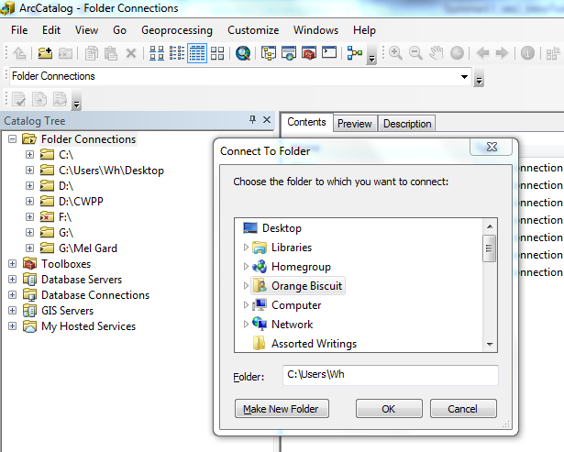

The new drive connection, its folders and contents should now appear in the Catalog Tree. Browse to the Lab1data folder by expanding the file folders (click on the “+” sign).

1. **What does the shapefile icon look like? There are 3 shapefiles (Cities, Rivers, States), and the icons all look slightly different. What do these differences represent?**
2. **What other file types are in the Lab1data folder?**

Now navigate to your Lab1data folder on your flash drive from the Windows Explorer—do the files appear different than when you were looking at them in ArcCatalog?

1. **When you are looking at the shapefiles in the Windows Explorer, how many pieces is each file comprised of? What are the functions of each extension? [Consult** [**ESRI’s ArcHelp**](http://resources.arcgis.com/en/help/main/10.1/0056/005600000003000000.htm) **for more info]**

***Tips: Managing GIS files in ArcCatalog***

To copy a shapefile from one folder to another, right-click on the shapefile name and select *Copy*, navigate to another folder location, right-click on the folder name and select *Paste*. To create a new folder, right-click on the desired location and from the dropdown menu, go to *New > Folder*.

Now, let’s explore these three datasets. In the C*atalog Display* (right-hand side window), you will see three tabs – *Contents*, *Preview*, and *Description*.

* Click on the *Preview* tab and then in the catalog tree click on each of your three datasets. Spend some time using the *Zoom*, *Pan*, *Full Extent,* *Identify,* and *Create Thumbnail* tools (part of the following toolset found near the top of the ArcCatalog window):

**Zoom In Zoom Out Pan Full Extent**



**Identify Create Thumbnail**

* Preview the Rivers shapefile. Switch to a preview of the attribute table - on the dropdown menu at the bottom center of the window, select the *Table* option:

**tableview**

1. **What attribute fields are included in the Rivers shapefile?**

* Find the “Miles” attribute and right-click to *Sort Descending*.

1. **What is the name of the longest river and how long is it?**  **What is unusual about this? (Hint: do a Google or Bing search on the river name.) What might this indicate about the data in the Rivers shapefile?**

* Now preview the States shapefile and click on the *Description* tab. Notice the image near the top of the page – it shows a screenshot of what you see on the *Preview* page. Examine the rest of the *Description* page.

***Note:*** The *Description* tab displays **metadata**, or documentation about your dataset.

1. **What type of information is included in the States shapefile metadata? Does this provide any indication of its source (i.e. who created the data)?**

* Return to the *Preview* tab for the States shapefile. Zoom into Oregon and Washington states using the *Zoom In* tool (click and hold down the mouse button, drag the cursor to draw a box shape, and unclick to finish the box).

1. **What do you notice about the shape of the two states?**

* Use the *Identify* tool to click on Oregon in the States shapefile.

1. **What was the population of the state in 2005?**

* Click on the *Create Thumbnail* tool then switch back to the *Description* page.

1. **What does the *Create Thumbnail* tool do?**

***A Quick Look at ArcToolbox***

From ArcCatalog, you can launch both the *ArcMap* and *ArcToolbox* applications. Let’s take a quick look at **ArcToolbox** (we will not spend too much time with it in this lab, but will revisit later in the course). Click the icon that contains a red toolbox:



Explore the contents of the *ArcToolbox* application. You can expand toolsets (groups of tools) by clicking on the “+” sign. If you right-click on the name of any individual tool, then select the “Help” option, an explanation of the tool will be displayed. We will revisit ArcToolbox when we get to Map Projections.

**PART III: ArcMap**

***Goal***: Create a map of major cities and rivers in the United States, including Alaska and Hawaii using the *ArcMap* application. Follow the instructions below and answer the **questions marked in bold**. Answers should be typed and well organized.

***Working with ArcMap***

Launch ArcMap using the icon furthest to the left that looks like a globe with a magnifying glass in front of it:



* A new, blank map document will open. Add the States, Cities, and Rivers shapefiles to the blank map by dragging them from the *Catalog Tree* in ArcCatalog over into the ArcMap window.

In ArcMap, you will notice on the right-hand side there is a “docked” window that is called “Catalog”. This is the alternate way to access ArcCatalog (as compared to the stand-alone application). Your folder connection (to your flash drive) should still display (if not, follow the folder connection steps described in Part II). Note: This is also an alternate way to add your data files to the blank map - you can click on your data files from here and drag them over into the map.

* Save the map onto your flash drive. Go to the *File* menu and select the *Save As…* option. Browse to the folder for your flash drive, type in the *File name* “ExploreUS”, then click the *Save* button.

1. **What three letter extension does your ArcMap document have?**

On the left-hand side of ArcMap is the *Table of Contents (TOC)* – the list of all of your map layers.

* Your map layers should be listed according to the order in which they are drawn on the map. Check to make sure that the *List by Drawing Order* button is selected at the top of the TOC:

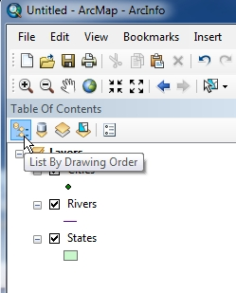

* You can move the layers around in the TOC by clicking and dragging the layer name up or down in the list. Move the layer names so that the States layer is on the bottom, and Rivers and Cities are visible on top of the states.
* By default, you should be in *Data View*. This can be confirmed by going to the *View* menu and seeing which view type (Data View or Layout View) is selected:

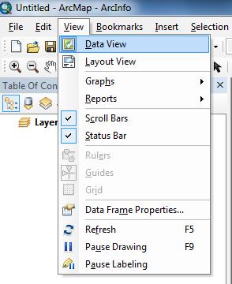

* Familiarize yourself with some of the tools on the ArcMap *Tools* toolbar:

**Zoom In Zoom Out Pan Full Extent Identify**

NavigationTools

**Fixed Fixed Return to Go to Next**

**Zoom In Zoom Out Previous Extent Extent**

* Zoom into the San Francisco Bay area in Northern CA using the *Zoom In* tool. There are a number of cities in this area. Use the *Identify* tool to click on a few of the points.

1. **What are the names and populations of two cities in the Bay area?**

* Click on the *Full Extent* tool so that you can see all 50 states again.
* Right-click on the Cities layer in the TOC and go to *Open Attribute Table*.
* After the attribute table opens, find the field named “POP2000”. Right-click on the field name (top of the column) and go to *Statistics*. This tool lists various statistical values for the selected attribute field.

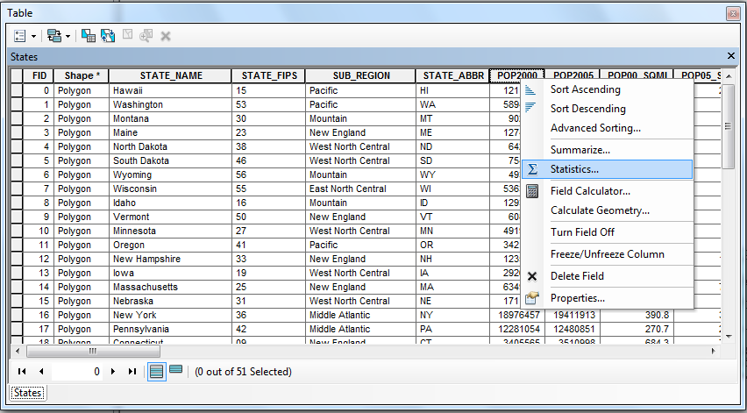

1. **What is the average (mean) of the all cities populations in 2000?**

* Close the Statistics box and sort the POP2000 field in ascending or descending order. (Use the same sorting method that you did in ArcCatalog.) Scroll up or down to find the city with a population that is closest to and greater than 50,000.

1. **What city had just over 50,000 people in 2000?**

* Select the city by clicking on the left-hand column (all the way to the left – the “grey column” without any column name). When selected, all information for that city will be highlighted in blue in the attribute table.

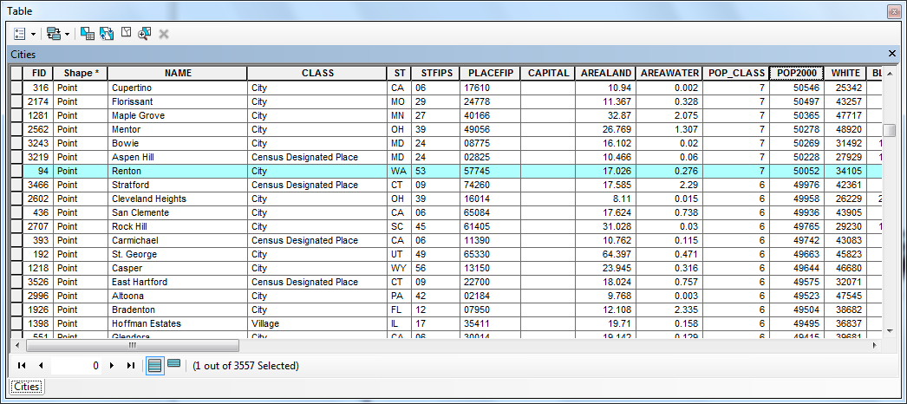

* Scroll to the top (or bottom depending on how you sorted your data) of the attribute table. While pressing and holding down the *Shift* key on your keyboard, click on the largest city – this will select all of the cities with a population greater than 50,000.

1. **How many cities are selected?**

* Without changing the selected features, close the attribute table.

1. **What color are the selected features on the map?**

Now you are going to create a new shapefile that contains only the Cities with a population of larger than 50,000 people.

* Right-click on the Cities layer in the TOC, and go to *Data > Export Data*.

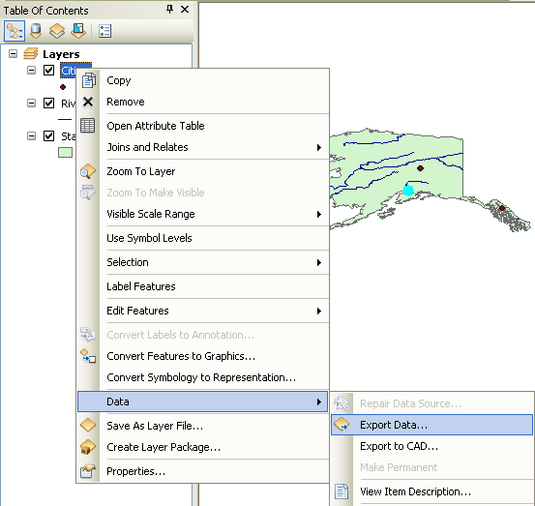

* In the *Export Data* window, export “Selected features” and use the same coordinate system as “this layer’s source data”. Click on the button with the yellow folder icon to open the *Saving Data* window. Browse to the folder for your flash drive, save as type “Shapefile”, and name the new shapefile “LargeCities”. Click the “Save” button to close the *Saving Data* window, then click the *OK* button to close the *Export Data* window. When prompted, click “Yes” to add the exported data to the map as a layer.

**Remember: When saving files in ArcGIS, only use alphanumeric and no special characters (e.g. *large_cities1* NOT *Large Cities $)***

* Click on the *Clear Selected Features* tool on the *Tools* toolbar.

**Clear Selected Features**

NavigationTools

* Turn off the original Cities layer (un-check it in the TOC), so that only the LargeCities, Rivers, and States layers are displayed on the map.
* Zoom into the state of Idaho. Using the *Identify* tool, find the cities of “Idaho Falls” and “Pocatello”. Close the *Identify* window when finished.
* Click on the *Measure* tool on the *Tools* toolbar and change the measuring units to “Miles”.

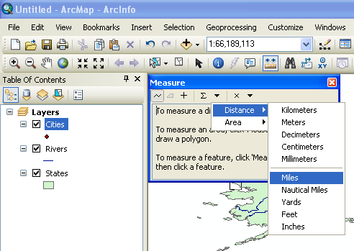

1. **Approximately how many miles (straight-line distance) is it from Idaho Falls to Pocatello?**

Close the *Measure* window, and click on another tool (e.g. *Pan*) to stop the work of the *Measure* tool. Now let’s make a few changes to how the map layers are symbolized.

* In the TOC, double-click on the States layer symbol – the *Symbol Selector* window will open.
* Notice that as you hover your mouse pointer over a color box, its name displays in a pop-up box. Change the Fill Color to “Lotus Pond Green” and the outline to “Gray 70%”. Click the *OK* button to apply your changes.

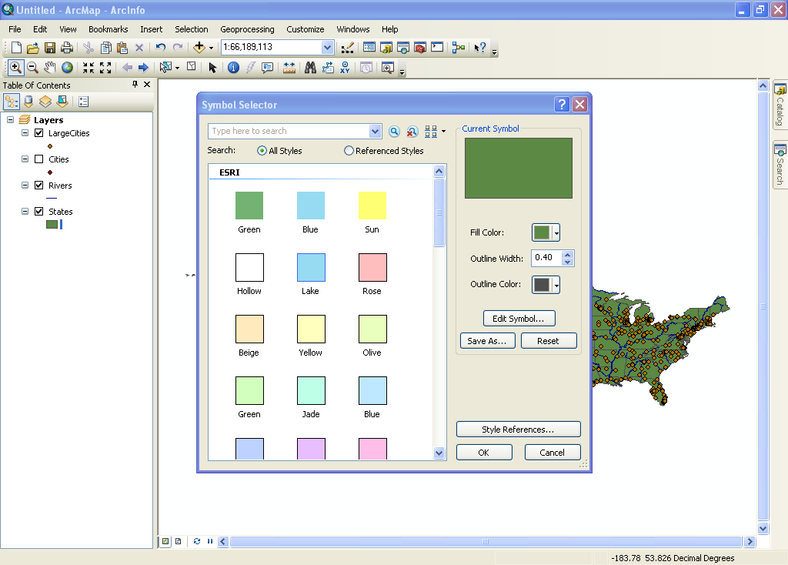

* Change the Rivers to the Color “Big Sky Blue”. Change LargeCities to the ESRI Style “Circle 2”, Size “8” and Color “Electron Gold”.
* Save your map file (go to the *File* menu > *Save* option).
* Switch from *Data View* to *Layout View*.

***Tip: Data View vs. Layout View***

*Data View* is used when you want to browse through your data layers and is your map window. *Layout View* is used to compose your map and looks like a sheet of paper.

One way to switch between the two views is by using the “View” menu at the top of the ArcMap screen – as you’ve already learned earlier in this lab.

Another way is to click on the small icons in the lower left-hand corner in the Map Display window.



Data View Layout View

**You will create a map that includes 3 data frames** - one of the lower 48 states, one of Hawaii, and one of Alaska. To do this, you’ll need to add two new data frames.

* Add the first data frame by going to the *Insert* menu > *Data Frame*. In the TOC, soft-click on the “New Data Frame” layer and rename it “Alaska”.

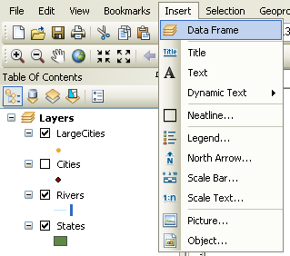

* Repeat to add a second data frame, and name it “Hawaii”. Rename your original data frame (originally called “Layers”) to “Lower 48”.

Your Alaska & Hawaii data frames contain no data, so they should appear blank.

* Click on States, Rivers, and LargeCities layers (while holding down on the *Ctrl* key on your keyboard) and drag them into the new data frames.
* In order to see Alaska in the newly created data frame, right-click on the Alaska data frame name and select *Activate*.

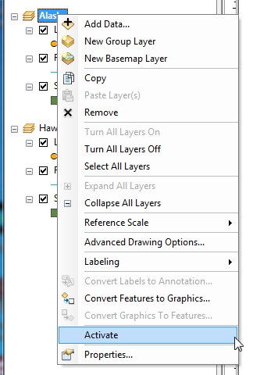

* Initially, you will see the entire US in this data frame - use the *Zoom In* tool to draw a square around Alaska. Once you are satisfied with your view, create a bookmark called “Alaska”.

***Tip: Creating a Bookmark***

Creating a bookmark allows you to always return to a specific view of the map data. Bookmarks can be shared with other map documents, which is helpful when you are making a map series or suite of the same region. To create a bookmark, go to the *Bookmarks* menu and click on *Create*.

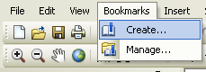

* Repeat the same steps in the Hawaii data frame (zooming into Hawaii) and create a bookmark called “Hawaii”.
* Change the map layout to Landscape orientation. Under the *File* menu, go to *Print and Page Setup*, look in the *Paper* section and select “Landscape”. Also check in the *Map Page Size* section to make sure that the “Use Printer Paper Settings” box is checked. Click *OK* to apply the new settings.
* Arrange all three data frames so that all the information is clearly present. Make the Lower 48 data frame the largest and the center focus of your map, with Alaska and Hawaii respectively placed in relation to the continental US (AK in the NW corner, and HI in the SW). Here is an example:

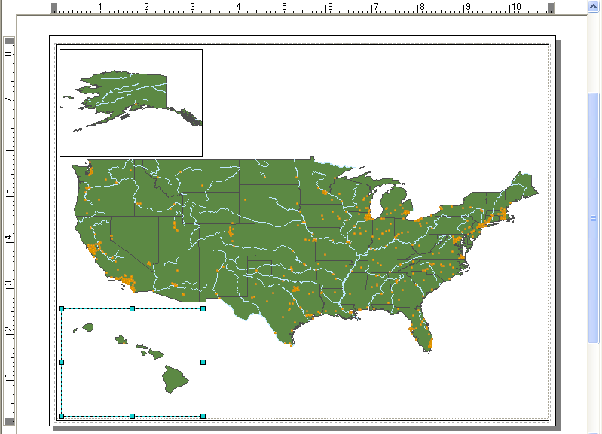

* To work with the data frames, click on the *Select Elements* tool on the *Tools* toolbar.

**Select Elements**

NavigationTools

* Move the data frames around by clicking on each one and dragging it around the page.
* Re-size a data frame when it is “active” by moving the small boxes in the corners of the frame.
* Insert a title box on your map layout (Go to the *Insert* menu > *Title*) and type your name in the box. Center the title box at the top of your map.

1. **Export the map in JPEG (*.jpg) format, and include it in your lab document.**

***Tip: Exporting Maps***

You can export your map in a variety of formats. For the lab exercises in this course, export as a JPEG. Exporting your map allows you to share the contents with others who do not have ArcGIS and prevents others from making any changes to your map. To export, go to the *File* menu and select *Export Map*…

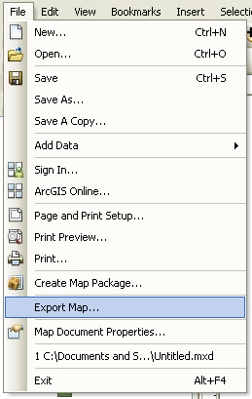

* Make sure that you save to your flash drive, and use a Resolution of 300 dpi.

