Lab 1|| Mapping Census Data

Introduction
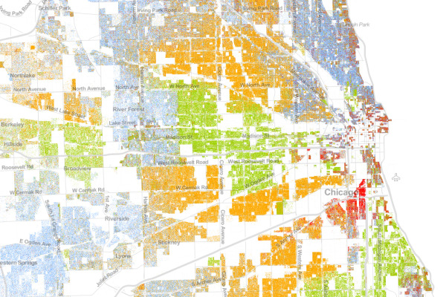
This lab is intended to be a review of tools and concepts from the Geo 265 - Introduction to GIS course. For those of you who have not taken the previous course at PCC, this lab will be a refresher/crash course and give you an idea of what prior knowledge is expected upon entering the analysis course. It will also introduce you to ArcGIS Desktop 10x tools and interface.

Before you begin this lab, take the time to thoroughly read through the instructions, in order to pinpoint topics that you may need to spend extra time reviewing.

In this lab you will review the following topics:
- Downloading geographic data
- Working with Projections
- Joining tables (.XLS files)
- Classifying data
- Developing Map design & production

Deliverables
Answer the questions marked in bold and produce the required outputs. Your lab document should be typed, well organized, and submitted according to the “How To” guidelines provided in the course syllabus.

PART I: Downloading & Projecting Boundary Files

First, a visit to the U.S. Census website. This is a big confusing website, but it contains a plethora of useful information, especially for mapping purposes.

- Go to the US Census website (http://www.census.gov/).

- On the Geography menu (across the top of the website), go to Maps and Data. Take a few minutes to explore the different links on this page.

- What type of information is available?

- Go back to the Maps & Data page and click on Tiger Products (under Geographic Data on the column on the right)

- There are a few different types of products on this page. We are interested in the Cartographic Boundary Files – click on the link on the website.

- What are the Cartographic Boundary files, and for what kind of mapping have they been designed?

- Click on Census Tracts. Check to make sure that the 2010 Census tab is selected.

- Select Oregon and click GO.

- Unzip the file and save it to your flash drive.

- Open ArcMap and add the Census Tracts file (gz_2010_41_140_00_500k). Save the map document.

- What is the coordinate system & datum for the 2010 Oregon census tracts shapefile?

- Is this a preferred coordinate system for mapping this particular data? Why or why not?

- Change the projection of this data set to the Oregon state based system – NAD1983 Oregon Statewide Lambert (international feet). Name the output file, OregonCensusTracts.

- What tool did you use to (successfully) change the projection of this file? (IMPORTANT: be sure to review the difference between the Define Projection and Project tools)

- How do you know that it has been successfully changed?

- If the new dataset did not automatically get added to the map, add it manually

- Remove the original dataset

- Does it look any different? Why or why not?

- Now – change the coordinate system of the data frame to NAD1983 Oregon Statewide Lambert (international feet) – same projection you used for the Census tract data set.

- Does it look any different now? Why or why not?

- Go to the Oregon Geospatial Data Library and download the counties (2007, 1:24000) and hwys (USGS, 1:2000000) datasets and add them to your map.

- Apply your cartographic skills to map this an easily readable reference map with all three layers. Be sure to include the necessary map elements.

- Export your map as a .jpg and add it to your lab document.

Part II: Downloading Census Tabular Data

Next, you will download the tabular (non-spatial) data available from the Census Bureau to join to your shapefile. With this data, you will make two maps using Income data from Oregon.

- Scroll back up to the top of the Census website and under the Data menu, click on American Fact Finder or follow the link below. (http://factfinder2.census.gov/faces/nav/jsf/pages/index.xhtml)

- To search through the Census data, we have to set up our parameters for the search – this includes our geographic area of interest and topics.

- Click on Advanced Search (show me all) to set up our parameters.

- We will start with our Geographic area of interest. Click on Geographies in the left side menu bar and a new window will appear.

  - Under ‘Select Geography Type’ click on Census Tracts.
  - Under ‘Select by State’ click on Oregon
  - Do not select a county
  - Highlight ‘All Census Tracts within Oregon’
  - Click on ‘Add to your selections’

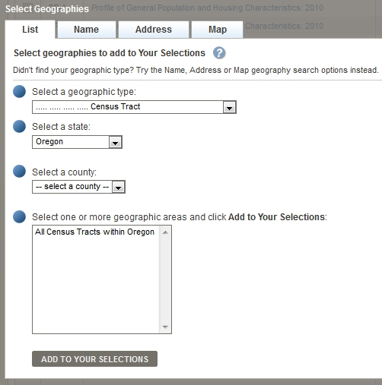

- Close the window (upper right-hand corner) and click on the Topics menu on the left. Under people, go to Income and click on Income/Earnings (Household). Close the window.

- In the list of tables in the main section of the website find S1901 ‘Income in the last 12 Months (In 2010 Inflation-Adjusted Dollars). Check the box and click on ‘Download’ located above the main list. (see screenshot below).

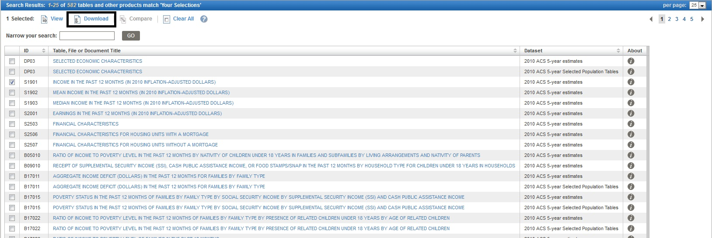

- You will be prompted to download a zipped file. Click OK.

- Click Download and save the unzipped file to your GIS folder.

Part III: Preparing Excel table data for ArcGIS

The purpose of preparing data in Excel first, instead of ArcGIS, is to simplify the data, focus on what you want to join and map, and create an optimal spreadsheet to import to ArcGIS.

When downloading census data, you often get numerous columns of irrelevant information. It is helpful to decide early on what you would ultimately like to display on your map. It is also helpful to derive new data from the given census data.

Delete unnecessary columns & rows

- Open up the ACS_10_5YR_S1901_with_ann.csv file using Microsoft Excel. Before making any changes, do a ‘Save As’ and save it to your flashdrive as Income2010.xls.

- There are a number of different columns in the file. The first three columns should be left alone throughout the exercise. Those will provide the information we need to identify the counties by name, and the ID number to join to the shapefile we downloaded in the previous section.

- We are only interested in following columns, which include the total number of households, household making less than $10,000, households making over $200,000, household mean and median incomes.

HC01_EST_VC01 | Households; Estimate; Total
HC01_EST_VC02 | Households; Estimate; Less than $10,000
 | Households; Estimate; $200,000 or more
  HC01_EST_VC11
HC01_EST_VC13 | Households; Estimate; Median income (dollars)
HC01_EST_VC15 | Households; Estimate; Mean income (dollars)

- To know what each of the columns represents in the table you downloaded, open up the ACS_10_5YR_S1901_metadata.csv file that came with the data your downloaded from the census. This is the table that provides Metadata (information or data about your data) for the income data. Take a few minutes to look at what all the other columns in your table represent.

- To delete all the unnecessary columns in your excel file, right-click on a column name you want to delete, and click on delete.

- To delete multiple columns at once, left-click on a column and drag the mouse over all the columns you want to delete. When they are all selected, right-click and click on delete. You may have to do this a few times to select and delete all the unnecessary columns.

- You will be left an excel file containing 8 columns – the five in the table above, and the first three ID fields.

Renaming Columns

- Change the names of the columns based on the table below.

Current | Meaning | New
 | Geo Identifier | GeoID
  GEO.id
GEO.id2 | Geo Identifier - abbreviated | GeoID2
GEO.display-label | Census tract & county information | Name
HC01_EST_VC01 | Number of total households | Households
HC01_EST_VC02 | Number of households making less than $10k | LowIncome
HC01_EST_VC11 | Number of households making more than $200k | HighIncome
HC01_EST_VC13 | Median household Income | Median
HC01_EST_VC15 | Mean household income | Mean

- Save the file.

- Why do you have to rename the column headings?

- Now change the name of the worksheet. On the bottom of the screen, right-click on ACS_10_5YR_S1901_with_ann.csv and click on Rename. Type in Income.

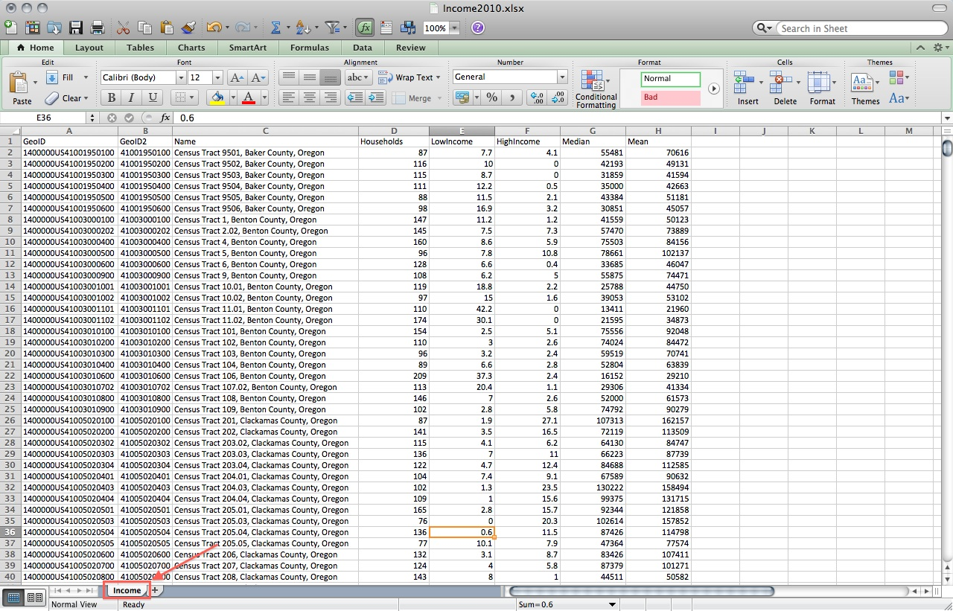

- Save and close file.

Part IV: Joining the Table to your Boundary File

- Open up ArcMap and start a blank new map. Save the map as CensusIncome.mxd to your flash drive.

- Add OregonCensusTracts to your map.

- View the Income2010.xls in ArcCatalog. Expand the file and drag the Income worksheet onto your map.

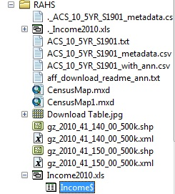

- Join the Income table to your OregonCensusTracts, keeping all records.

- What is your primary key for this table join from each table?

- Did the table join correctly? How can you tell?

- If the table joined successfully, export the dataset to a file geodatabase, naming the new feature class “OregonIncome”

- Why do you have to export the data to a new file?

- Now to map the data – go into the OregonIncome layer properties.

- Make ONE choropleth map from this data. You can map out the whole state or zoom into to a metropolitan area (such as Portland) for a finer geographic scale. Here are a few options for map topics:
  - Average Household Income
  - Highest (or Lowest) Household Income.
  - Median Household Income
  - Total Number of Households

- Apply your cartographic skills to map this a clear choropleth map. Be sure to include the necessary map elements.

- Export your map as a .jpg and add it to your map document.

PART V: Create (another) Census Map
Practice, practice, practice!

- Go through this exercise again, following the guidelines / steps below:
  - Download another boundary file (something other than census tracts) from a state other than Oregon.
  - Project your boundary file to an appropriate projection for your chosen state or region
  - Explore the American Fact Finder to map another characteristic / variable
  - Download your table and prepare the table to be used in ArcGIS
  - Join the table to your boundary file
  - Export the file (to make it permanent in the form of a geodatabase feature class)
  - Create a map of your data (using cartographic principles)

- Export your map as a .jpg and add it to your document.

