Lab 4 | Cartographic Techniques

Introduction

In this lab you will learn a variety of different techniques that are used to produce Cartographic effects. This includes, drop shadows, coastal vignettes, hillshades, custom symbols, and 3D choropleths. Some of these techniques can be done with the standard ArcGIS tools, and others are from add-in toolboxes like Terrain Tools.

Copy the Lab4data folder to your flashdrive.

Deliverables

Your lab document should be typed, well organized and submitted according to the “How To” guidelines on the course website (one document (PDF) with all of your exported maps).

Part I. Creating Figure-Ground
Creating a figure-ground separation in our maps is one of the core cartographic design principles.

- Creating a simple drop shadow
One way to promote figure-ground is to use a ‘drop-shadow’ effect, where a shadow is drawn around the ‘figure’ to make it appear as if it is ‘popping out’ from the rest of the map. You can do this in ArcMap using Cartographic Representations and the ‘move’ geometric effect.

- Open Africa.mxd.

- In the table of contents (TOC), right-click on DRC and click ‘Convert Symbology to Representation’. Accept all defaults and click OK. A new layer should appear in your TOC.

- Go to the properties of the new layer, DRC_Rep, and go to the Symbology tab. Under the ‘Solid color pattern’ click on the color patch and change the color to Gray 70%.

- Click the ‘+’ button at the top right (just above the Solid color pattern). When the Geometric effects pop up window appears, select the ‘Move’ effect and click OK.

- Change the x and y offsets to 2 and -2, respectively and click OK.

- Move the DRC layer on top of the DRC_Rep. You should now have a simple drop shadow that promotes figure-ground.

- Label the Democratic Republic of Congo. Change the colors of the DRC & Africa if you would like to. Export your map and paste it into your lab document.

- Creating a gradient drop-shadow
If you want to use a gradient pattern drop shadow, rather than using a solid color pattern you will use a gradient pattern. The gradient effect gives the drop shadow a softer edge.

- In the TOC, right click on DRC_Rep and go to properties. On the Symbology tab, under Rule_1, click the arrow next to the ‘Solid Color Pattern’ heading and click on Gradient.

- Change Color 1 to Gray 10% and Color 2 to black. Use the HSV algorithm and Buffer style. Change the Intervals to 100, Percentage to 5, and Angle to 0. Change the x and y offsets to 3 and -3, respectively. Click OK.

- Export your map and paste it into your lab document.

- Creating a Coastal Vignette
Using gradients to display a smooth transition between colors is another subtle way to separate or highlight features in your map (creating figure-ground). This gives features a ‘glow’ effect.

- Open Americas.mxd

- There are two layers on this map – Americas (land) and Ocean_Western (water). This map has two bookmarks – Caribbean and Nunavut. Both of these areas are places where you will be able to see the ‘glow’ effect in detail.

- Open the symbology tab for Ocean_western and click on the symbol. Go to Edit Symbol.

- Change the ‘type’ to Gradient Fill Symbol. In the Gradient Fill window, change the Intervals to 20, percentage to 0.3, and style to ‘Buffered’.

- Right-click on the color ramp, and using the HSV algorithm, click on Color 1 and choose Sugilite sky (hover over the colors to see the names). Then click on Color two (the same color blue should appear in the color box). Click on the color box and go to more colors. In the color selector, choose HSV, and change the saturation to 10%. Click ok twice.

- Check your settings with the screen shot below.
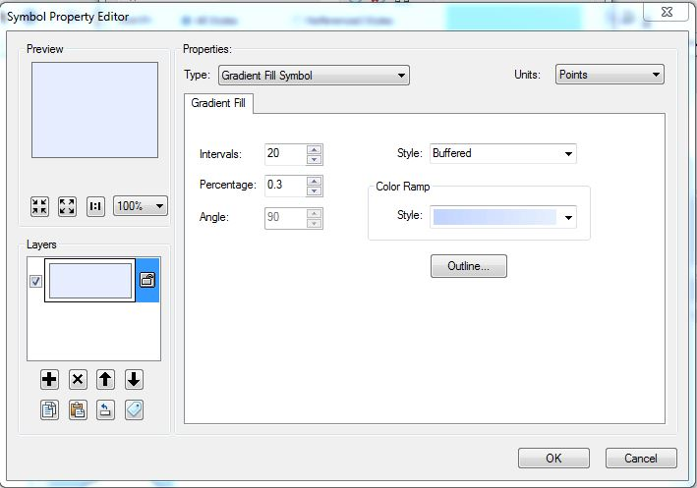

- On the Symbol Selector window, change the outline to no color (or make the width 0). Click ok until you can see the map.

- Zoom into an area (Caribbean or Nunavut are good examples) where you can see the ‘glow’ effect in action.

- Create a map that includes some labels and any necessary map elements, where you clearly see the glow effect. Export and add the image into your map document.

Part II. Creating a custom symbol
There are times when you cannot find an appropriate symbol within the default ESRI symbols. When this happens, you can create your own symbol. There are two ways to create a new symbol – modifying an existing one or creating a new one from the ground up.

- Open Seattle.mxd.

- There are several different categories of landmarks included in this data set. Choose one landmark (or category of landmarks) and create a custom symbol that appropriately represents the landmark.

- You can use the following resource from ESRI for details on how to manipulate an existing symbol or create a new one: http://desktop.arcgis.com/en/desktop/latest/map/styles-and-symbols/about-creating-new-symbols.htm

- Give your map a title and any other necessary map elements. Export your map and paste it into your lab document.

Part III. Creating Graphs
You can create graphs in ArcGIS to visualize and explore data. It is a good way to summarize your data and/or to present the data in ways other than just the map. In this exercise you will take crime data in Portland and create a graph (in addition to a map) that summarizes the data by quadrant.

- Open CrimePDX.mxd

- Go to View>Graphs>Create Graph to open the Create Graph Wizard

- You will start off by creating a Vertical Graph, so select that in the Graph Type options. The Layer/Table will be Vandalism_2014_byQuads and the value field will be Count, which represents the total count of reported vandalism incidents in 2014. Set the X Field to Quadrant. Check the box next to ‘Show Labels (marks). And uncheck ‘Add to legend’. Click Next.

- Change the Title of the graph to Vandalism. In Axis Properties, change the Left axis title to # of Incidents. Click Finish.

- Similar to when we worked on creating legends, there are advanced settings in the graphing tools that are only accessible once the graph has been created. After it appears in a floating window on your screen, right-click in the graph to see some options – you can add it to your layout, save it, export it, print it, and go to (advanced) properties.

- Right-click on the graph and go to Advanced properties. This is where you can change the fonts, colors, borders, and all the other fine details of the graph. The changes will automatically show up on your graph and you make them, so you can see what is being changed and its appearance.

- Under Chart, click on General and then click on the Fonts tab. Change the fonts for the Title, Left Axis, Left Axis title, Bottom Axis & Bottom Axis title to a Sans Serif font of your choice (not Arial). Customize the size, style, and anything else you feel necessary.

- Under Chart, go to Walls, and uncheck ‘Visible Walls’.

- Next click on Data. In order for the quadrants to show up on the bottom axis, type in the quadrant names for each category (refer to the map to know which one is which) using the directional abbreviations (i.e. NE). Those abbreviations will now appear on the bottom axis.

- Lastly, we will change the appearance of the data vale labels on the graph (marks). Under Series, click on Vertical Bar and then click on the Marks tab.

- Under the Marks tab, click on Format and go to Color and change it to white; then click on Border tab and go to Frame and uncheck ‘visible’; go to Text and change the font to the same font you used for the other text on the graph; next, under Marks, go to Shadow and uncheck ‘visible’.

- Now, let’s save the graph (just to be safe). Right-click on the graph and go to Save. Save it as a graph to the Vandalism geodatabse in your lab folder.

- Lastly, we will add the graph to your map. Right-click on your graph and click on “Add to Layout”. This is still a dynamic link, so if you make any additional changes to the graph properties (through the wizard), it will automatically change on the graph.

- To get some more experience with graphs – make one additional graph to include on your map. You can use the existing data (Vandalism) or you can go into the Vanadlism.gdb and find a dataset that includes a Count of all crimes by neighborhood.

- With both graphs on your map (or possible two maps, each with a graph), add a title and any other necessary map elements, export, and add into your lab document.

Part IV. Creating Hillshades
In this exercise you will use tools available through Terrain Tools, a toolbox of geoprocessing tools that produce cartographic effects for terrain representation. This is a toolbox that you will need to download and connect to ArcToolbox.

- Download & install Terrain Mapping tools
- Before getting started, go to: http://www.arcgis.com/home/item.html?id=4b2ea7c5f87d476a8849c804b81667aa and download Terrain Tools. When it is done downloading, unzip the folder and place it on the T Drive (if in SS110) or somewhere on your hard drive (if working from home). This will include a toolbox (Terrain Mapping), as well as documentation, some practice data sets, and color ramps (styles).

- After unzipping (extracting) the files, open ArcToolbox from within ArcMap. At the top of the window where it says ArcToolbox, right-click and ‘add toolbox’. Go to the Terrain Mapping toolbox and add it to your toolbox. Once that is done, it should appear in list of Toolboxes. Expand the folder so that you can see the tools that are available.

- Multi-Directional Oblique Weighted (MDOW) Hillshade
Multi-Directional Oblique Weighted (MDOW) hillshade produces a hillshade that emphasizes oblique illumination on all surfaces by using more than one illumination azimuth (which is the method used in the Hillshade tool that is built into ArcGIS).

- Open a blank .mxd and add the Clackamas DEM & Hillshade from Lab 3 (can be found on the course website).

- In ArcToolbox, expand the Terrain Mapping toolbox and open the MDOW hillshade tool. The input raster is the Clackamas DEM. Give the output hillshade a name and save it to your flash or hard drive. Keep the z factor at 1. Run the tool.

- The new hillshade should be added to your map.

- Before symbolizing the DEM, you are going to add the Color ramps provided by Terrain Tools. Go to Customize>Style Manager. Once the Style Manager opens up, click on the Styles button and then go to Add Style to List. Navigate to the ColorRamps3.0 folder (from the Terrain Tools download) and add the five .style files. Close the Style Manager

- Make sure that the DEM is above the MDOW hillshade in the TOC.

- Go to Symbology for the DEM under properties. Change the color ramp to ‘NorthAmerica_Region_SierraNevada’. To see the names of the color ramps, right-click on the ramps and uncheck ‘graphic view’. Go to the Display tab and change the transparency to 50%. Click ok to close the properties.

- Zoom into an area where you can clearly see some detail – toggle between the MDOW hillshade & the ‘regular’ Hillshade – with the DEM on top. Check out the differences between the two.

- In layout view, create a map with two dataframes so that you can show the differences between the MDOW & regular Hillshade (each data frame should include one of the hillshades with Dem on top).

- Add a title for the two data frames and include a brief description on the map comparing the two hillshades – what are the visible differences between the two? Export the map and add into your lab document.

- 3D Choropleth
The 3D Choropleth tool provides a way of enhancing the normal representation of a choropleth map by building a series of shadows and symbolizing them by mimicking the casting of shadows from an illuminated NW light source. It is building a ‘hillshade’ from a polygon feature class and uses attributes to create the choropleth.

- Open Colorado.mxd

- There is a Colorado county feature class on the map that includes an attribute, Democat_percent, which is what we will use to create the 3D Choropleth.

- First – we need to fix an issue with the python script in the 3D choropleth tool. There are three lines in the code that point to a “TempLyr” file, and that file does not exist. To do this right click on the 3D Choropleth tool in ArcToolbox (in Terrain Mapping). Go to Edit and the script will open in Notepad.

- In Notepad, go to View, click on ‘Status bar’. If you click in the code, you will see a bar at the bottom that show you the line (Ln) and column (Col). Go to line 88, and delete the whole line (delete the full line and make sure that there is no longer a ‘blank’ line either). Next, go to Line 102 and delete the whole line. Lastly, go to line 121 and delete the whole line. Notice that each line was similar and all pointed to that “TempLyr” that does not exist. Click Save and close Notepad.

- Back in ArcMap, open the 3D Choropleth tool. For some unknown reason, you cannot drop and drag a dataset into the Input features. Go to browse and select the CO_Voting feature class from the Colorado.gdb

- The Choropleth value is Democrat_percent, and the browse to the Colorado.gdb for the output workspace. Keep all other settings as is and click ok.

- A new group of layers will appear in your map when the processing is completed. Move the original CO_voting into the group, just below the short_lyr. Click off the (or remove) the other CO_Voting.lyr in the group (should be just a single color symbology).

- Now, you can mess around with the transparency and other display settings of the 4 layers until you get a look that you are satisfied with. Below is a screenshot of (approximately) what it should look like.
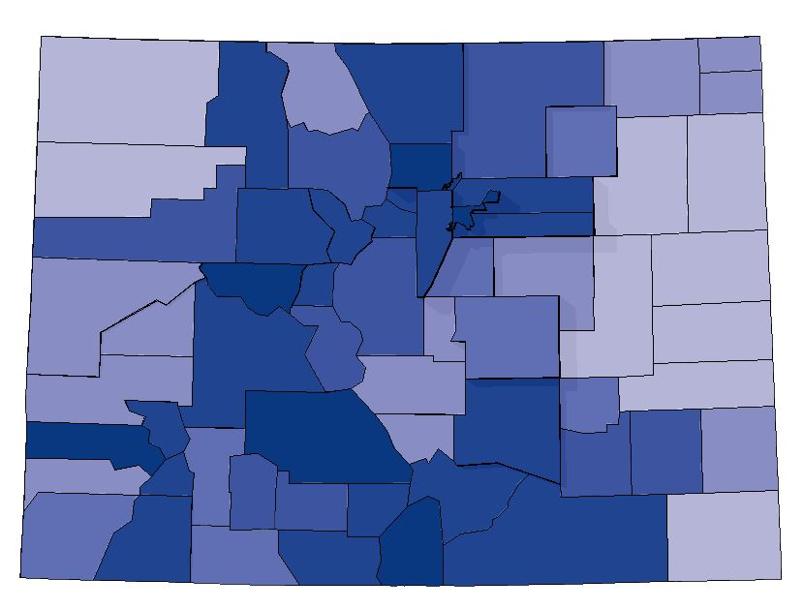
- Create one map to get a similar effect to the image above. Add a title, legend, and any other map elements you think necessary.

- Export your map and add into your lab document.

- Now, have some fun! Change the colors, change the display setting and experiment with the different sizes of hillshades given with the data (short, med, and long). See what kinds of different visual effects you can create with the data and this tool.

- Add the necessary map elements to v2 of your 3D choropleth, export your map and add it to your lab document.

- Explore other Terrain Mapping tools
Here is a chance to explore of the other tools that are available in the Terrain Mapping toolbox.

- In the Terrain Tools folder you downloaded, there is a folder called ‘doc’, which contains a PDF, TerrainToolsDocumentation. This provides a description of all the tools available in the toolbox and some basic instructions for using the tools.

- Chose one of the other tools (not MDOW or 3D Choropleth) and run it using data of your choice (you can also continue with the Clackamas DEM or the sample data provided with Terrain tools).

- Create a map that includes the results in a map, any necessary map elements, and a text description of the tool and results.

- Export your map and add into your lab document.

