Lab 1. Exploring Google Maps & Earth
Google My Maps let you quickly and easily make custom maps and share them with others. This tools allows you to:

- Draw and style points, line & polygons
- Manage your maps in Google Drive
- Edit your maps
- Import data from Google sheets, .csv, excel, or KML
- Embed maps into a website

Instructions.
Following the instructions below, you will import data, create a map, and explore the functionality of Google Maps. Answer any questions in bold.

Google Account.
You will need to use your Google (non-PCC) account to create a Google Map.

Part I | Google Maps.
- Log into your Google Account and go to Google My Maps (https://www.google.com/mymaps).

- On the Welcome page, click on Create a New Map.

- In the upper left-hand side of the screen, click the text Untitled Map to edit the map title and description. You are going to be mapping Bike Crash data from the Portland Metro area is 2014. Give your map the title, ‘Bike Accidents, 2014’ or something similar to that. You will come back later in the lab to write the Map Description.

- Open up the PDX_BikeCrash.csv in excel and take a few minutes to look through the data. You can also use the documentation provided (in Lab1data folder) to help understand some of the column titles for the attributes. The table includes data on location (county, city, urban area), roads (classification, speed, name, type), and the crash itself (type of injury, hit & run, drug or alcohol involvement, etc).

Importing data.
- First, we will import this .csv file into the Map. In the menu, select Import.

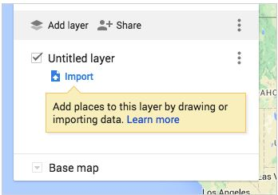

- Select the PDX_BikeCrash.csv from the Lab1data folder.

- After uploading the data, it will ask you to select which columns have location information so that you data can be correctly placed on the map. In this case, you have the lat/long coordinates. Check the Lat_DD (latitude) and LongTD_DD (longitude) and click Continue.

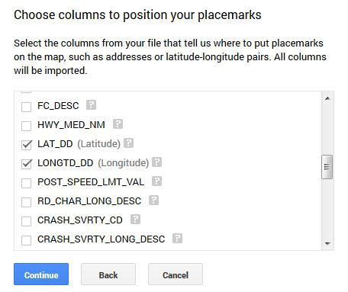

- Now you can pick the column you’d like to use to title your markers. Check Crash_SVRTY_LONG_DSC and click Finish.

- You should now see your data as a layer in the menu and your points plotted on the map. If you would like to change the name of this layer in the menu, you can select the text of the layer name and change it. By default, the layer name will be the file name.

- Now, let’s upload a second data layer. Click Add Layer.

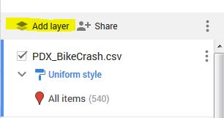

- Go through the same steps to import the MetroCities.kml. When you are finished you should see both layers appear in the menu and on your map.

- You can also add data to your map by manually creating point, lines or polygons from the menu.

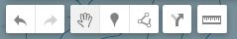

- You can either create a new Layer (Add Layer) to do this or highlight a layer in the menu to add features to an existing layer.

- Add a new layer and draw in a line or polygon (make it relevant to the map data in some way).

- One more feature to highlight – Add Directions (the arrow in the menu above). You can add a layer to your map that shows directions from two (or more) points. Give it a try!

Stylizing your data.

- Let’s start by changing the Base Map. The Base Map colors/style will influence how you want to represent the other data layers. Scroll down the Map menu and click on the drop-down menu next to Base Map. Your options for base map styles will appear. Select a style of your choice.

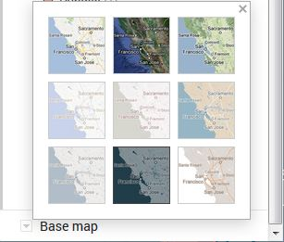

- Next, let’s customize the Cities data, which is currently represented as Individual Styles. Go to the Cities layer in the menu. Click on Individual Styles and change it to a Uniform Style (no labels). Then, hover your cursor over All items (53) and a paint can icon will appear on the right. Click on the paint can.

- Selecting the paint can will pull up a menu of choices for colors, transparency, and Broder width. Customize each of those options so that it works well with your Base Map style.

- Now – the Bike Crash data. There are a few ways that we can symbolize this data since it has a number of attributes in the table. Hover your cursor over All items (540) and click on the paint can when it appears. It pulls up a menu of choices for colors and shapes. If you select More Icons, even a larger selection will appear. At the bottom of that screen you will also see an option for ‘Custom Icon’, which allows you to upload an icon or search Google Images to find one. Choose an icon & color that you find work wells for representing the data.

- Next, add the Bike Crash .csv again (repeat steps from earlier), so we have two layers on the map and can symbolize each one differently. Once the new layer is added, click on Uniform Style (and you might want to shut off the first bike crash data layer to make it easier to see) and let’s Style by Data Column. I will let you choose which data column to represent, but will walk you through one example.

- Under the Style by Data Column, click on ALCHL_INVLV_FLG column (this is showing which bike crashes involved alcohol, 1=yes, 0=no). Use the Categories option.

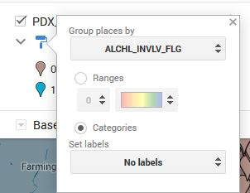

- Close the menu and then you can individually select colors for each category.

- Explore the options here – if you choose a column that is numeric and has a large range of values, you can use the ‘Ranges’ option to classify the data into groups. If you want to look at the data table, go to the Layer Options and Open Data Table.

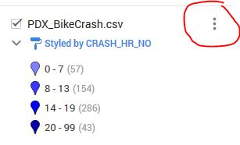

- Customize this data layer to represent one attribute from the table of your choice, making sure that you are using a color scheme appropriate to the type of data (quantitative v. qualitative).

- Under the options for symbolizing the data, you can also select if and what attribute you want to label the data. Since the Base Map already has city names, we do not need to label them. But, go ahead and create a label for one of you Bike Crash data layers, as you see appropriate.

Editing your data.
- You can easily make changes to your map data at any point in the map-making process. You may want to do this if you notice a typo or want to add (or delete) information to your info window. Click on any data point or polygon on the map and you will notice that a pop-up window appears with all the data from the original table.

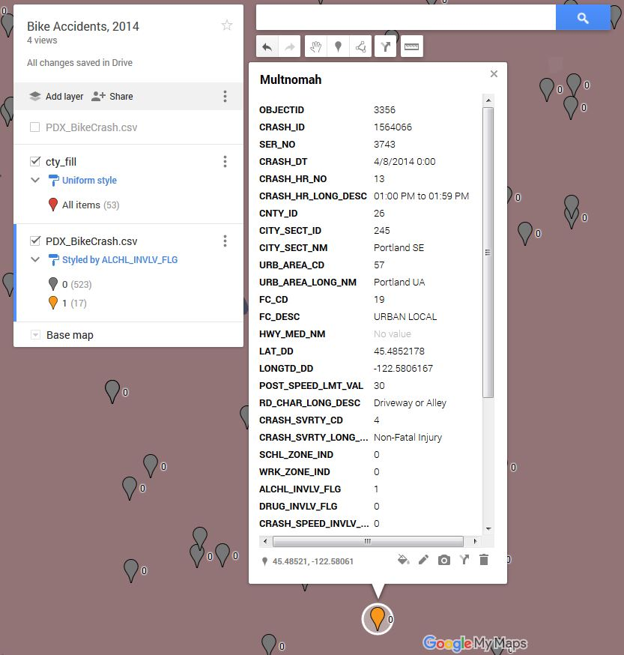

- If you click on the pencil icon at the bottom of the info window, you can edit the data directly from this window.

- Alternatively, you can make changes to your data from within the table view (you did this earlier by clicking on the Layer Options and selecting Open Data Table). You can make changes to your data by click on any field in the table view. The table and info window are linked, so any changes you make will be reflected in both places. You can add rows to your table or you want to show more places, or delete an existing row.

- In the info window, you can also

  - change what column in your table is being used for the Title (Top of the info window)
  - Add a photo or video

- Customize your info windows for the 2nd Bike Crash data layer you created in the previous section. Feel free to delete rows if you want to limit what data is being displayed.
- Now that you have a better understanding of your data and what you are representing on the map - click on the Map Title and write a description for your map.

Share & Embed your Map.
Once your map is all finished, you have options for how you can share this with others. All maps are private by default, which means only you, as the creator of the map, can view or edit it. You have the option of making the map public and embedding it on a website, sharing it with specific people, or allowing anyone with the link to the map to access it.

- Click on Share in the map menu (right next to Add Layer). The screen (below) will appear.

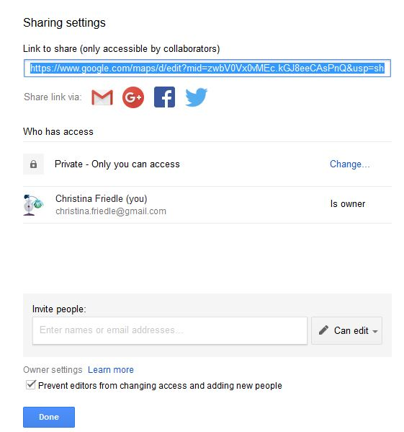

- Click on the ‘Change’ to see options for sharing.

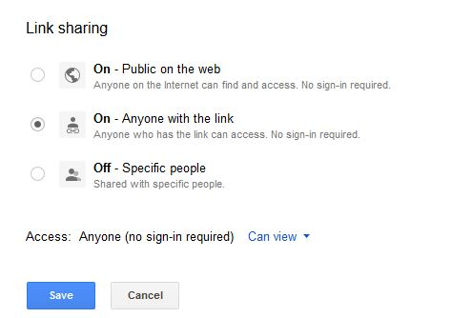

- Change the settings to On- Anyone with the link.

- Post your link in the Assignment dropbox in D2L to submit your lab.

- You can choose to make the map Public on the web and further refine your share settings so that it is either viewable or editable by the public.

- Sharing your map also allows you to collaborate or work with a group of people on the same map (just like other Google file types). You can invite specific people to share the map and give them Edit access. If you share your map with a Google Group, each member of the group will have access to your map.

- If you want to embed your map on a website you need to make it Public. Once it is public, go to the Map menu and next to the Share button, you will see three vertical dots. Click on the dots and go to Embed on my site. Copy the HTML code and paste it into the source code of your website. Note that you can customize the height and width of your map in the HTML code.

Setting a default view for the map.
- It is possible to set the default view for the map so that whenever it is displayed it automatically goes to the view. Position the map in your web browser the way that you want it to be viewed. Go to the Map menu pulldown (three dots next to the Share button) and select Set Default View.

Accessing your Google Map.
- You Google My Map is saved to your Google Drive just like any other google document.

Export to KML.
- Google My Maps can also be used to generate geospatial data and then export as a KML for use in other web mapping technologies. Back in the first section, there is a description on how to create points, lines or polygons on the map. If you want to create a data layer of information in Google My Maps, once you are finished, you can export as a KML. To do this, go to the Map menu pulldown (three dots next to the Share button) and select Export to KML.

