Lab 1b. Exploring Google Earth

Google Earth allows you to see 3D terrain features, create flyover tours, and add your own content. It is a client-side application, which must be installed on your computer, as opposed to Google Maps, which only requires a browser. If you don’t already have Google Earth on your computer, you can download & install it now. Google has now made Google Earth Pro available at no cost – use your email address and the Key: GEPFREE to login.

http://www.google.com/earth/download/gep/agree.html

Instructions.
Following the instructions below, you will import data, create a map, and explore the functionality of Google Earth. Answer any questions in bold.

Part I | Google Earth.
Open Google Earth to get started.

- Zoom into to Oregon, either by using the zoom controls, or by typing Oregon in the Search box.

- For now, shut off everything in the Primary Database, except for Borders & Labels. This will just make it easier to look at.

- Since we will taking advantage of the 3D features in Google Earth, let’s make sure that 3D Imagery is enabled. Go to under Tools>Options and click on the 3D View tab. Under Terrain, check (if it isn’t already) the box next to Use 3D Imagery.

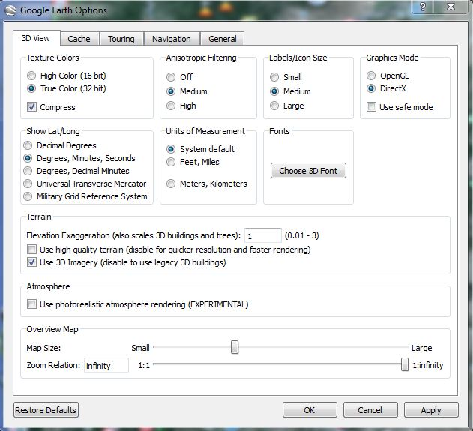

Adding placemarks and features.

- Before we get started with creating new data in Google Earth, let’s create a folder to add it to. Go to Add>Folder and give it a name (i.e. Oregon Points of Interest). This will appear in My Places.

- Across the top of the screen, you will see the main Google Earth Toolbar

- The push pin symbol on the left is the Add Placemark tool. Click on the tool and it wil add a new placemark to you map. You can pick up the push pin and move it wherever you would like on the map. In the pop-up window that appears, you can also give the Placemark a name, description, and change the icon/color of the symbol representing that point.

- You are going to create placemarks for several features found in Oregon. If you have trouble finding a location, use the Search box to find it. Add placements for the following locations (first read through the next few steps):

  - Mount Hood
  - Crater Lake national park
  - OMSI
  - Washington Park (Oregon Zoo)
  - High Desert Museum
  - Oregon Coast Aquarium
  - Multnomah Falls
  - Oregon Caves
  - Lan Su Chinese Gardens

- For each placemark, add the name of the feature and a short description. Change the symbol to something that is befitting to the feature and makes the map cohesive.

- Change the view of your placemark by changing the camera perspective. This can be done for each placemark when creating the feature under the View tab or after the feature is created by right clicking on the feature in the Table of Contents and going to Properties>View>Heading and Tilt.

- You can also add pictures to your placemarks – these pics need to be online (just like with all the other programs we have used). You can do a Google Image search to find suitable pictures, just make sure that you do not use any pictures that are copyrighted.

- Add pictures to at least 3 of your placemarks. To add pictures to a placemark’s balloon, right-click the placement and select properties. Then click on the Add Image button. In the image URL box, paste the URL to the image you want to use, then click OK.

- The HTML code for the picture will appear in the description box. You may also add any text description in the box, then click the OK button at the bottom of the Edit Placemark box.

Creating a Viewshed.
It is now possible to create a viewshed directly in Google Earth. A viewshed is an area that is visible from a specific point or location. It includes the area around that point that are in the line-of-sight and excludes anything that are beyond the horizon or obstructed by terrain (and sometime other features like buildings or trees).

- In your ‘Places’, right-click on the Mt. Hood placemark and go to Show Viewshed. You will probably get a warning that ‘Your placemark is too low’. If you do, click on Adjust automatically. Google Earth will calculate the viewshed from your Mt. hood point.

- When it does calculating, go to File>Save>Save image. The view in GE changes – a legend appears, as does a north arrow, scale bar, and title/description. Give your map a Title & Description and include all other map elements. You can edit what is visible in your legend my clicking on it (same goes for the title & description).

- When you are finished, click on ‘Save Image’ and save the image as a .jpg.

- Add the Viewshed map into your lab doc.

- Close the map image and exit the viewshed view.

Adding path & polygon features.
In addition to adding points on Google Earth, you can also create lines & polygons for other types of features.

- Go to (or search for) Trillium Lake on Mt. Hood.

- Select the Add polygon tool (on the Google Earth toolbar) and draw a polygon to trace the lake (as best as you can). When you finish drawing it, name the polygon and adjust the transparency so that you can see the imagery below it.

- Next, use the Add Path tool to trace Trillium Lake Road from where it intersects with HWY 26 to Trillium lake. Refer to the image below to get an idea of where it is (it is visible on the imagery in Google Earth). Change the color of the line and make it a line thickness of 2 pts. Name the path, Trillium Lake Road.

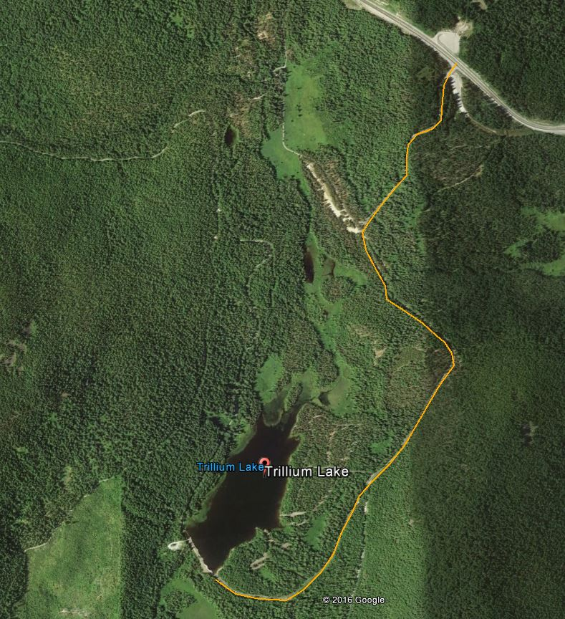

- By default, paths are positioned or ‘clamped’ to ground level. You can change the appearance and create interesting view by positioning the path above the ground. Rick-click the path in My Places and click Properties. Click on the Altitude tab. Switch from ‘Clamped to ground’ to ‘Relative to ground’ and type in 300m (about 1000 ft). Click on ‘Extend path to ground’. Click OK on the properties window. Your path should now appear above the surface.

Import GPS data.
Google Earth allows you to import GPS data in two ways – you can connect a GPS unit directly to your computer and import data from it or you can import data in a standard GPS file format such as .gpx. Unfortunately, Google Earth does not import GPS files directly from the Trimble Juno – you must convert it first in Pathfinder Office into a .gpx, .kml or .shp.

For this example, you will import data as a .gpx file (in Lab1data folder).

- Go to File>open. When the file browser opens, navigate to the Lab2Data folder that contains a GPS file, ponds. IF YOU DON’T SEE IT – you need to change the file type to GPS. Select the file and click Open.

- It should fly you over to Portland and show you Whitaker Ponds in NE Portland.

Create a tour.
A unique feature of Google Earth is the ability to create tours, in which you can highlight points of interest. If you have a microphone available, you can record a voice narration along with your tour. You are going to create a tour highlighting the features you created in Oregon earlier in the lab.

- Click the Record a Tour button on the toolbar. The recording buttons will appear at the bottom left-hand side of the screen.

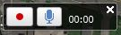

- If you have a microphone and want to add some narrative, click on the microphone button to enable it.

- Zoom back out to the state of Oregon as an initial extent. Click on the button with the red dot to start the recording. The timer should start counting the time while you are recording.

- With the recording in progress, pan and zoom your map to the points of interest you created. Or you could double-click the points in My Places , which will make the map zoom to each point. Make sure to zoom to each point and give a brief narration, if possible.

- You might have to practice the tour a couple of times before you are ready to save it and call it final.

- To finish recording, click on the red button again. When the playback slider appears, you can play back your recording.

- On the playback slider, you can save your tour. Be sure to save the tour!

- Once you have the Tour in My Places, right-click on it and go to Save Place As and save the KMZ file to your flash drive or hard drive.

- When you submit your lab doc, you will also attach the KMZ of your Tour.

Creating & Adding Overlays.
You can either create or find an image that you can overlay on top of the Google Earth imagery/data. When you create an overlay, it integrates with the terrain or shape of the land beneath if the terrain layer is turned on. One way to use this is to take a map that you created in ArcMap and overlay it in Google Earth to show the data over a more detailed base map, including terrain and any other features that may be available.

- The image you will bring in is a 1948 Topographic map of the Portland/Vancouver vicinity. Go to this area in Google Earth (approximately).

- Click on the Add Image Overlay tool on the Google Earth Toolbar. Go to Browse and search for the Vancouver, WA 1948 image. Give the overlay a descriptive name.

- In the google earth viewer, you can use the green markers to stretch and move the image a number of ways to get the image positioned correctly. You will also need to change the transparency so that you can see what is below the image.

- Take some time to accurately place the image. When complete, click on the Terrain features under Layers and zoom around so you can see how that is incorporated into the image.

- Turn on the Historical Imagery (clock icon on the Google Earth Toolbar). Compare the 1948 topo map with the earliest imagery available.

- What are some major differences and/or similarities between the two images?

Sharing & Saving your Google Earth project.
With Google Earth, you can typically save your content in KML or KMZ format (KMZ is just a zipped version of KML). The convenient part about this, is you can send anyone else that KML or KMZ file and when they open it (assuming Google Earth is installed on their computer), it will automatically open in Google Earth.

- Rick-click on your project folder and click Save Place As and save it to your flash drive or hard drive as a KMZ (and give it a name).

- MAKE SURE THAT ALL THE POINTS, LINES, POLYGONS, IMAGE, ETC. are in the folder you save so I can see your work!

- When you submit your lab doc, attach the KMZ or the places you created for the lab.

