Lab 2. Introduction to ArcGIS Online (AGOL)
ArcGIS Online is a cloud-based platform which allows users to create and publish web maps, and share them online. You can also organize and participate in groups which allow participants to collaborate on mapping projects. To read more about it, go to: https://doc.arcgis.com/en/arcgis-online/reference/what-is-agol.htm

Generally speaking, access to ArcGIS online is subscription-based, with various levels of functionality, which corresponds to cost. There is a public account that is available at no cost that allows for basic functionality. The public account allow you to upload .csv files, create dot maps, share & publish to an external website. There are also trial versions of ArcGIS Online, which have extra functionality, but it only lasts for 30 days.

For this class, you will be sent an invitation to join the Oregon Community Colleges ArcGIS organization. This will give you full access (with the exception of geocoding) to AGOL functionality. This invitation will arrive in your email. Follow the instructions in the message to activate your membership in the OCC organization. After you accept the invitation, it will take you to your profile page. Fill out your profile, as is appropriate for the course.

Instructions.
Following the instructions below to become familiar with the basic functionalities of AGOL. Answer any questions in bold and follow instructions for lab submission.

Part I | Getting Started with ArcGIS Online

Sign in to AGOL.
- Follow the link: https://portlandcc.maps.arcgis.com/home/index.html and Sign in using your username & password. This will take you to the OCC home page that should look like the image below.

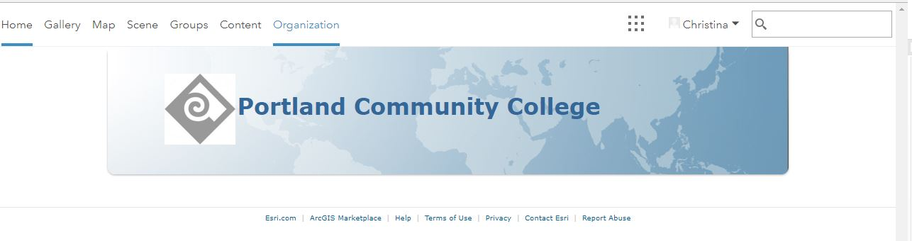

AGOL Groups.
Groups allow you to share your maps with other interested parties and to collaborate on map projects. Groups can be public (anyone can join) or private (invitation only). When you are using a public account, you are only allowed to create public groups.
- Click Groups (top of the screen) on the interface to create or explore your groups. A group has been created for this class. If you are not already part of the group, search for ‘Interactive Map Design 2018’ and request to join.

Start Creating an Online Map.
Once you have an account and can sign in, you can start building a web map.

- Click on the ‘Map’ link at the top of the page. It will bring you to a screen that looks like this:

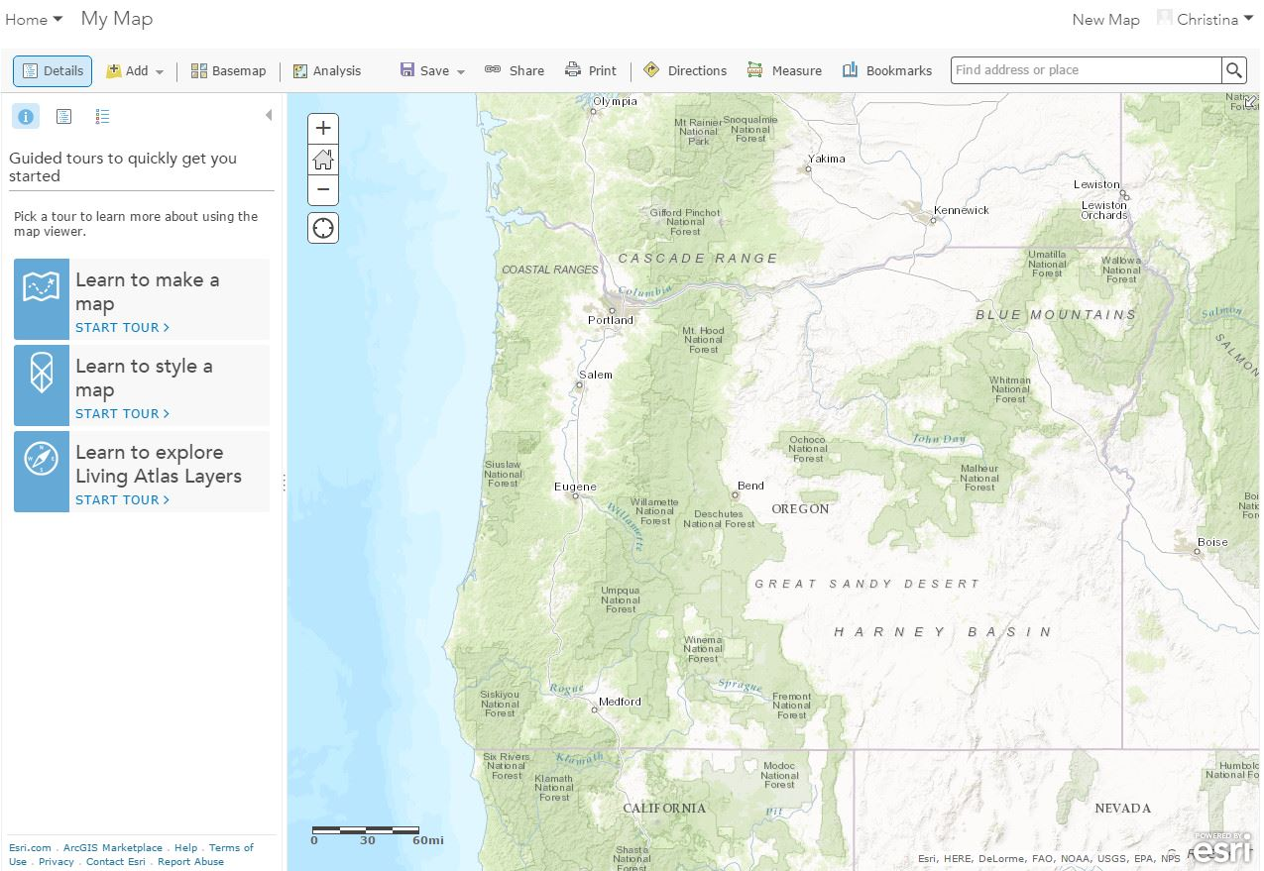

- This is where you will start building your map within AGOL. Notice on the left-hand side there are some links to some basic instructions to help you build your map. You can go through those steps, although this lab will also walk you through those and more.

- As with most interactive maps, you can zoom in and out using the + and – buttons. You can also pan the map view by clicking and dragging it around.

Changing the basemap.
Let’s start by changing the basemap. The same options are available here as are in ArcGIS desktop.
- Across the top of your map, click on Basemap to show the gallery.

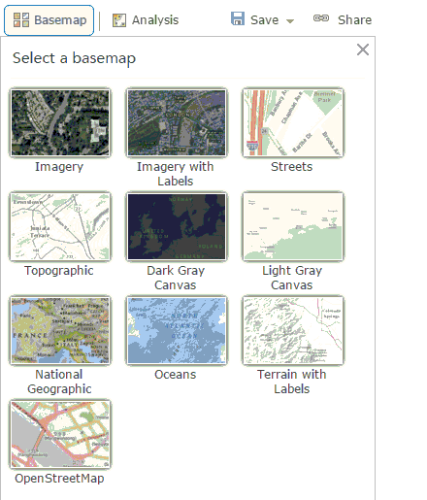

- Take a few minutes to select different basemaps, taking note of the differences between them all.

- Choose one style of basemap – tell me which one you chose and provide an example of when you might use this style of basemap.

Finding locations or points of interest.
On the right side of the top toolbar, notice the box next to the Bookmarks button that says, Find address or place. As the title suggests, this allows you to type an address or known location (i.e. Portland, OR or Oregon Zoo) and the map will zoom to it.

- Type in an address of a location you know, including the city, state, and possibly zip code. Or you can type in Portland Community College, Sylvania. Click on the magnifying glass to zoom the map to that location. *Note* depending on which basemap you are using, you may see a message that your map cannot be viewed at that scale. If so, trying zooming out and/or switching your basemap.

- Take a few minutes to explore, using the pan & zoom functions, selecting from different basemaps and finding locations by address or name.

Measure tool.
The measure tool is similar to the tool you find in ArcGIS desktop. It allows you to measure lengths, area, and spot location by clicking and dragging your mouse.

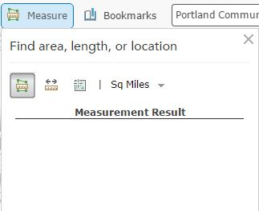

- Take a few minutes to experiment with measuring area & distance. You can also use the Location tool to get coordinates for any given location.

- What is the Lat & Long (in degrees) for the top of Mt. Sylvania?

Saving the map.
Before you go any further, let’s save your map project. This is not automatically done in AGOL, so if you create a map and do not save it, it will not be there the next time you open AGOL!! Very important to know!

- Go to the Save button on the toolbar.

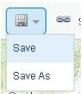

- Click on Save. The first time you save a new map, you will need to enter some information in order to save it.

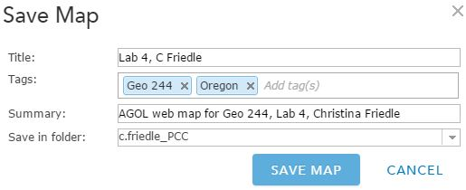

- Enter a title for your map. And use the tag, Geo 244, and any others you think are applicable. In the summary box, please include your name, and any other information you want. You can leave it in the default folder. Click on Save Map when you are finished.

- As always, SAVE YOUR WORK OFTEN!!!

Opening a previously saved map.
If you signed out of your AGOL account or otherwise need to open a previously saved map, you can sign in again and click the My Content button. Going to My Content will take you to a page that has all your maps listed, as well as any apps or data layers you have created (or uploaded). To open a previously saved map, click on the map in the list of Content. It will take you to a page describing your map. From there click the Open button and go to Open in map viewer.

Adding data to your map.
Adding data to your AGOL map can be done in several ways. We will try out a few of them here.

- Wherever you might be in your map, zoom in or out so that you can see the whole state of Oregon.

- First, let’s try adding data from the existing online services. Click the Add button on the toolbar and select Search for Layers. When the Search for Layers tab opens, type in “Oregon” (without the quotes). And change the In box to ArcGIS online. Make sure Within map area is checked.

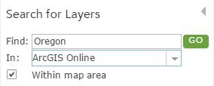

- This should return a list of existing data layers within Oregon that you can add to your map. When I did the search I got over 1400 results. If you click on the title of any of these layers, more information about the data will appear (metadata). Look through these layers, and when you find one that interests you, click Add to add it to your map.

- What layer did you add? Who posted it? Look at the Item Details (metadata) – what does it tell you about this layer?

- After you add your layer of choice, click on Done Adding Layers and the bottom on the screen to close the tab.

- Next, let’s try adding uploading data to your project – you can add several types of data this way including .txt, .csv, .gpx, as well as zipped shapefiles. Go to the Oregon Geospatial Data Library (http://spatialdata.oregonexplorer.info/geoportal/catalog/main/home.page) and download a shapefile of your choice (just make sure it’s not too big). When you download the file, it should be zipped. Save it to your flash drive or hard drive.

- Go back to your map in AGOL and click the Add button on the toolbar and this time select, Add Layer from File. To add the shapefile data, choose the file from your computer using Browse. Click Import Layer.

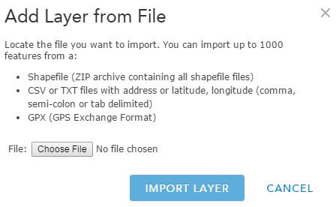

- You should now have two data layers on your map and they should both be visible in our Table of Contents, along with your basemap.

Symbolizing data.
Now, let’s play around with the data symbolization to be something more appropriate than the default.

- First, let’s take a look at your map legend. Across the top of your Table of contents, click on the Legend button.

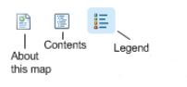

- The legend will show you how each category or data layer is being represented on the map. Click the Contents button again to see the list of your layers. Each layer has a checkbox next to it that will turn the corresponding layer on or off. If you hover over the data layer, underneath the data layer name you will see:

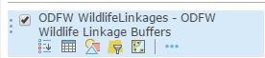

- Starting the from left, the symbols represent: Show legend, Show table, Change Style, Filter, Perform Analysis, More options. If you hover over any of them, the name will appear.

- Go to Change Style and your options for either of your datasets will appear. Depending on whether you have points, lines, or polygons, your option will appear differently. And depending on whether you have qualitative or quantitative data in your table, your options will appear differently.

- Take a few minutes to explore each of the different possibilities of symbolizing your data. When you find one that you think represents the data most appropriately, click on Done so that it applies that style to the data on your map.

Adding Map Notes.
Another way to add data to your map is by drawing features using Map Notes. With Map Notes, you can create a layer and add shapes to denote points of interest. You can add points, lines, and polygons; change their styles; add descriptive text; and add URL’s to relevant information.

When you create a Map Note, it only exists within your map project – you cannot export them as a shapefile or any other format.

Let’s add a Map Note to test it out.

- How about we add a map note for PCC Sylvania campus? Zoom in to the proper location – you can do this using the Find Address or Place box, or by manually zooming in.

- On the toolbar, click the Add Button and select Map Notes.

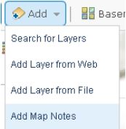

- The Add Notes box will open. Fill in the boxes as shown below and click Create to create a new layer called PCC, Sylvania.

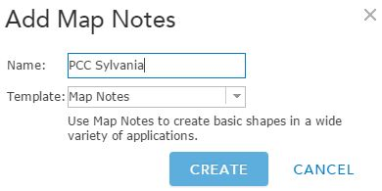

- The Add Features appears in the area of the Table of Content. You have the option to add a point, line, polygon, or text. Let’s keep it simple for now and add a point. Click on one of the point symbol icons (your choice) to select the type of point symbol to be drawn.

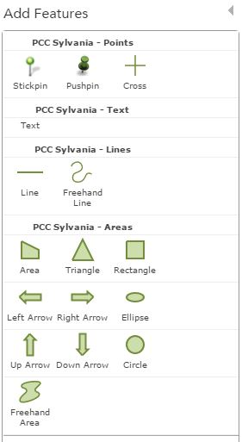

- Now, move your cursor on to the Map and click to place the point at the campus location. A point symbol is placed on the map and the following box appears:

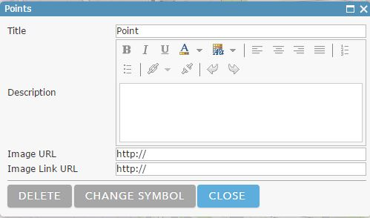

- Enter PCC Sylvania as the title, and write a brief note in the Description box.

- Map notes will also allow you to add links to more information about the location and an image. You will create a link to the PCC website, using the PCC logo as a clickable image. In the Image URL box, add https://pbs.twimg.com/profile_images/577891822489378817/czmzgM6u.png

- Next, in the Image Link URL box, add http://www.pcc.edu/

- Click on the Change Symbol button and use a symbol other than the default.

- When all is ready, Click the Close Button. Save your map.

- You can add as many points, lines, polygons or text for this layer of Map Notes. You can choose to play around with some of the other Add features tools.

- When all is ready, go back to the Table of Contents (click on Details) and on your map, click on the PCC Sylvania point you created. You should see something like this:

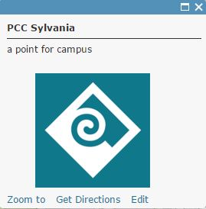

- To know if everything is working correctly, click on the PCC logo and the pcc website should open in your browser.

Adding Bookmarks to your map.
Some of you probably use bookmarks in your maps in ArcGIS desktop – well, you can use them in AGOL as well. Bookmarks are helpful because they allow you to return to a specific map view any time you want.

- Zoom into the PCC Sylvania location. Click on the Bookmarks button on the toolbar and when the box opens up click Add New Bookmark. Type PCC Sylvania, hit enter, and then close the Bookmarks box.

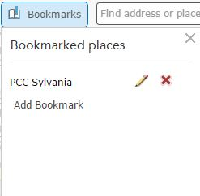

- Now, move the map to any other location and add another bookmark there. Now, at any point you will be able to go to the Bookmarks menu and select those bookmarks you created to take you back to the exact map view. Try it!

Exploring your data.
There are ways to explore the attributes of your data as well – using Identify features & view your data attribute table – similar to ArcGIS desktop.

- Click on one of the points from the data you brought in from the Oregon Geospatial Library. The attributes for that feature will display in a popup.

- To see the full attribute table – click on the ‘Show Table’ icon below the layer name in the Table of Contents. The data table will open and allow you to view all records in the layer.

- Click on one of the records in the table (highlight/select it). Then go to Table Options (upper right side of the table) and go to Center on Selection. The map should automatically zoom you to that feature and have it centered on the map.

- You can also ‘Filter’ your data based on a certain attribute. This is just like writing a query, but you don’t have to use SQL. Explore this tool a bit and see how you can filter your data based on a specific attribute.

- One more thing I would like you to explore are the Pop-ups. Just like with many of the Google products we have been learning, you can configure your Pop-up windows to only show specific attributes or to add photos. Click on the “More options” icon on one of your data layers (looks like three horizontal blue dots under the layer name in Table of Contents). Click on Configure Pop-ups. Create a custom pop-up for your data layer.

Finalizing your map for submission.
At the end of this lab, you should have:
- At least three data layers (one from AGOL, one from Oregon Geospatial Library, and one Map note),
- All three layers stylized/symbolized,
- At least two bookmarks,
- Custom pop-ups,
- A chosen base map

- Take all of the above requirements and make sure that they make a comprehensive, understandable map – one with a purpose. Share the map with the Interactive Map Design 2018 group, and include the URL to your map in your lab doc.

How to share your map with the Interactive Map Design 2018 group.
At this point, your map has been created but you are the only one that can view or access the map. With AGOL, maps can be shared with everyone (made public) or confined to selected group. For now, I want you to share it with the Interactive Map Design 2018 group.

- Click the Share button on the toolbar. Check the box for the Interactive Map Design 2018 group.

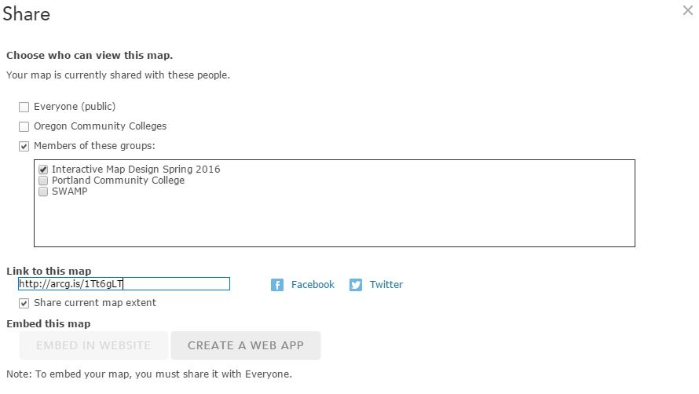

- Before closing the dialog box, copy the link in ‘Link to this Map’ and insert that URL into your lab doc.

