Lab 3. A little more with ArcGIS Online (AGOL)
In the previous lab you were introduced to the basics of ArcGIS online. You created an account, creating a new map, added various types of data to the map and started to share it with the group. This lab will focus on building on those skills and demonstrate some additional features and functionality of ArcGIS online.

Instructions.
Following the instructions below to become familiar with the basic functionalities of AGOL. Answer any questions in bold and follow instructions for lab submission.

Part I | Additional functionality of AGOL

Editing geospatial data.
AGOL allows the ability to edit some types of data layers. It is possible to create Hosted Feature Layers – these are layers that are stored in the cloud on the ArcGIS online server. This is one advantage to web mapping – it allows you to collaborate with others, and add or update your data.

You have already explore some data types you can upload and add to your maps, such as shapefiles and GPS. You can also create data layers from spreadsheet data in .csv format. The spreadsheet should have columns containing coordinate data in order to place the locations of features.

For this section, you will first create a hosted feature service by uploading your spreadsheet, then you will add it to your web map, enable editing, and perform a few edits.

- In AGOL, go to My Content to open up your content page. At the top of the Contents list, click the Add Item link and add from your computer.

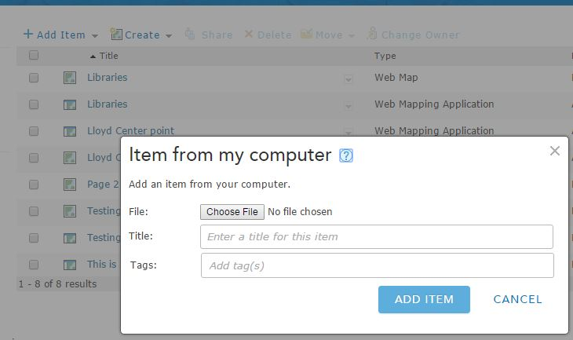

- Go to Choose File and select the BensonBubblers.csv from the Lab3data folder.

- Change the title to Benson Bubblers, and add a few tags. Click Add Item.

- A new Item from my computer window will appear. Make sure that the ‘Publish this file as a feature service’ is checked. And set your Location fields as shown below.

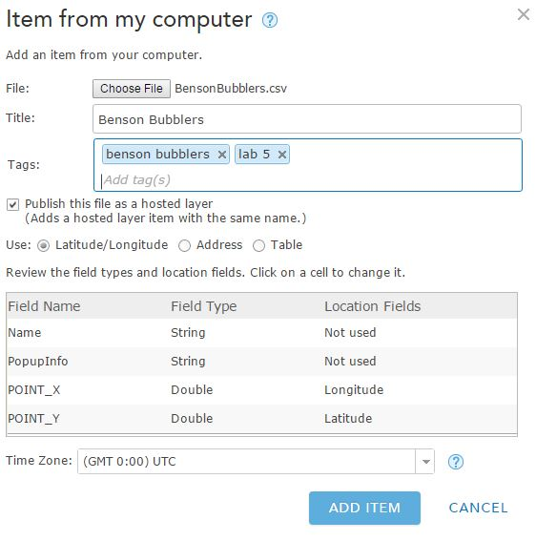

- Click Add Item. The feature service will be created. It should now appear on your My Content page. By default, it will not be shared so others will not be able to see or edit it.

- Locate the layer on your My Content page and click the title. The layer’s property page will display. Click the Share link and the Share window will appear.

- Share the layer with the Interactive Map Design 2018 group.

- Go to dropdown menu under ‘Open in Map Viewer’ and ‘Add to new map with full editing control’

- A new map will open with the Benson Bubblers layer on it. First, we are going to change the symbols to a Single Symbol (your choice!). When you are finished, click Done to return to the Contents.

- There’s a couple of ways to start editing your data. In order to have full editing access (to all features at once), click on the Edit button on the top menu. Zoom into one of the bubblers and click on the feature. The feature’s attributes will appear in a popup.

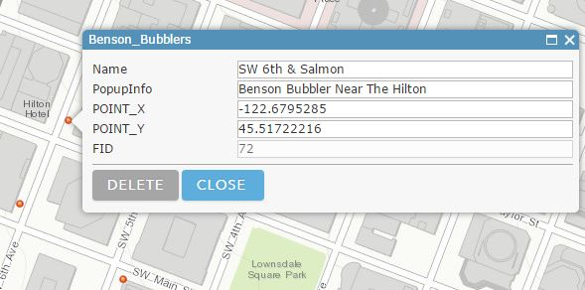

- You can edit the attributes by typing them in the appropriate fields. Change the Name & pop-up info to whatever you choose.

- Note: editing the latitude & longitude values will NOT change the location of the feature. To move the feature you can drag it with your mouse.

- If you need to delete a feature, click on Delete. Click Close when you are all done making your edits.

- When in an editing session, you can also add new features (the Add features window should have appeared when you first clicked on Edit). Each layer has its’ own features that can be added depending on how things are symbolized.

- There are a couple of Benson Bubblers that do not appear in this file and we are going to correct that. The missing Bubblers should be located at:
  - NE Holladay & Wheeler (One Bowl)
  - SW 5th & Oak (Benson Bubbler)
  - SW Front & Ankeny (Three Bowl)

- Locate the three addresses above on the map (you can use the search bar), and in each location, click on the New Feature for the Benson Bubblers and then click on your map to add a new feature.

- The attribute pop-up will appear when you add the new feature. Be sure to populate these values. When you are finished, click Close.

- Symbolize the three points that you added to the map differently than the others and keep it this way so that I can easily find your work.

Analyzing data with AGOL.
In addition to using AGOL to create and publish maps, you can also run a number of analytical tools on your map data. There are quite a few tools available, but for this lab we will create buffers around your newly-created Benson Bubblers layer.

- Before we create the buffers, click on the Analysis button and spend some time looking through the geoprocessing tools that are available. Please remember that each time you run a tool it takes ‘credits’ from our account.

- Are there any tools that you are unfamiliar with from ArcGIS desktop?

- Pick two tools and explain what you could do with them (click on the little ‘i’ icon next to each tool). Does it seem easier to more difficult than working with tools in the Desktop version?

- In the Perform Analysis window, click on Use Proximity to show the tools available.

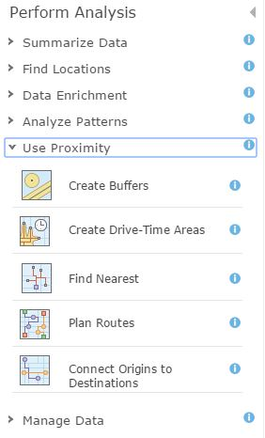

- Click on Create Buffers to open that tool. We are going to create a multi-ring 100, 500, 1320 feet from bubblers. Make sure to select the Benson Bubblers layer, put in the three distances (separated by a space), go to options and select the dissolve type and rings. Uncheck the ‘use the current map extent’ and click Run Analysis.

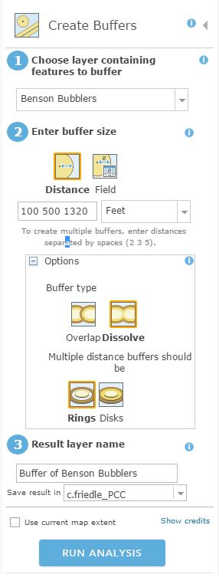

- Are there two or more Benson Bubblers within 100 ft of one another? How can you tell?

- Next, we will create a density of the bubblers so that we can view it as a ‘heat map’. Click on Analysis, and this time go to Analyze patterns. Click on Calculate Density. Select the Benson Bubblers are the layer. There is no count field. Click on Options to see what can be changed. Set the search distance to 1320 ft (1/4 mile). Choose a classification type and the number of classes. And make sure that the box ‘Use Current Map Extent’ is not checked. When finished, click Run Analysis.

- What pattern emerges when looking at the data as a heat map?

- Based on the other data layers you brought into your map – choose one additional analysis to run on one of your other data layers or using more than one layer. Please do not run them multiple times! As I mentioned, this uses credits towards our account.

- What analysis did you run? What were the inputs and parameters that you set?

Include all your new analysis layers in your map and Save your map.

Part II | Creating a Map Application

Creating a Map Application.
AGOL offers a suite of configurable apps that can help bring your stories your life. For most of the apps, once you have the map created, the majority of your work is complete. Choosing an app has some built in functionality that will make your map more useful to your users. To find out more about specific functionality in the configurable apps go here: http://doc.arcgis.com/en/arcgis-online/create-maps/choose-configurable-app.htm

- There should now be 4 layers on your map, all related to the Benson Bubblers. Choose a basemap for your map. And make sure all your layers are symbolized the way you want.

- When you are satisfied with how your map looks and functions, click on the Share button. Share the map with the Interactive Map Design 2018 group. Then, click on Create a Web App. A pop-up window will appear that shows you all the available web application templates.

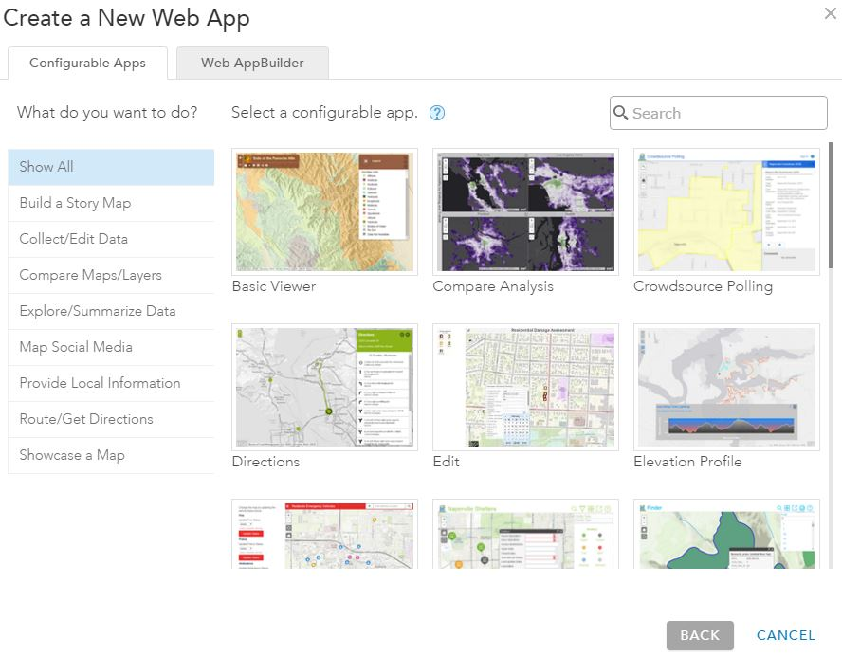

- Take some time exploring the different options for web applications. These are pre-determined apps that are helpful when you want to have a starting place for your map application. Since I want you to learn the ins and outs, you will be using the Web AppBuilder to build something custom.

- Click on the ‘Web AppBuilder’ tab and provide a title and some tags (if it is not already populated) and click on “Get Started.”

- First thing you will be prompted to do is Pick a Theme. The different themes target different types of use:

Foldable and Tab: intended for more complicated apps - support all widget types
Billboard: intended for simple apps
Box: provides a clean look with widgets turned off by default
Dart: On-screen widgets turned off by default
Jewelry Box: designed for apps with a workflow
Launchpad: Intended to mimic the Apple Mac style

- In the theme tab, explore how the different themes look. Notice that the page layout options change with different themes. You may need to use the slider bar on the side of the window to see the different layout options. Pick a theme that you like for your web app, and select a layout option. Pick a theme that has a header or a sidebar.

- Change the style to a color you like. Note that the last style option allows you to pick a custom color.

*Saving your map* at any point in the creation of your Web App, you can click on the Save icon at the bottom of the screen. You should do this frequently to ensure your work is not lost**

- Click on the Map tab on the top menu. This is where you set the Map Properties – selecting which web map you want to use in your app. Since you started with a map, it should already be showing the Benson Bubbler map.

- This is also where you set the Initial Extent of your map, and the Customized Vewable Scales. Set the Initial Extent to show the full range of your data.

- Limiting the viewable scales for your map can be helpful if your map is intended to show a limited spatial extent (in that case, why zoom out to the entire world?) or if you don’t need to zoom in to the city block scale. The scales are standard Google zoom levels, and it may take some trial and error to figure out which ones to remove. Customize these scales, so that the user can only zoom in and out as is necessary for this map. If you make a mistake, you can always choose to reset the initial scales.

- Click on the Attribute tab on the top menu. The attributes tab allows you to change the title, add your name, add a branding logo, and add links.

- Modify your map title and add your name. Add an image into the Logo (benson bubbler?).

- Save your app; remember to save often as you work through additional steps so that you do not lose your work.

- Click on the Widget tab. The widget tab allows you to configure and add widgets to your map. Widgets are either data independent, or data dependent. Data independent widgets are generally quite simple to configure, and some of them do not even have options. Data dependent widgets are configured using the attributes of data layers on your web map.

- Each theme has a certain set of common widgets already added to your app, such as a zoom slider, search, scale bar, etc. Explore what each of these default widgets for your theme actually do. If you hover your mouse over the widget, you will see an option to edit the widget properties (pencil), or to hide the widget (eye).

- Configure each of these widgets if there are options to do so. You can choose to hide widgets that you think are not appropriate.

- Below the default widgets are placeholders for additional widgets. Click on the first placeholder and you will see the available widget options.

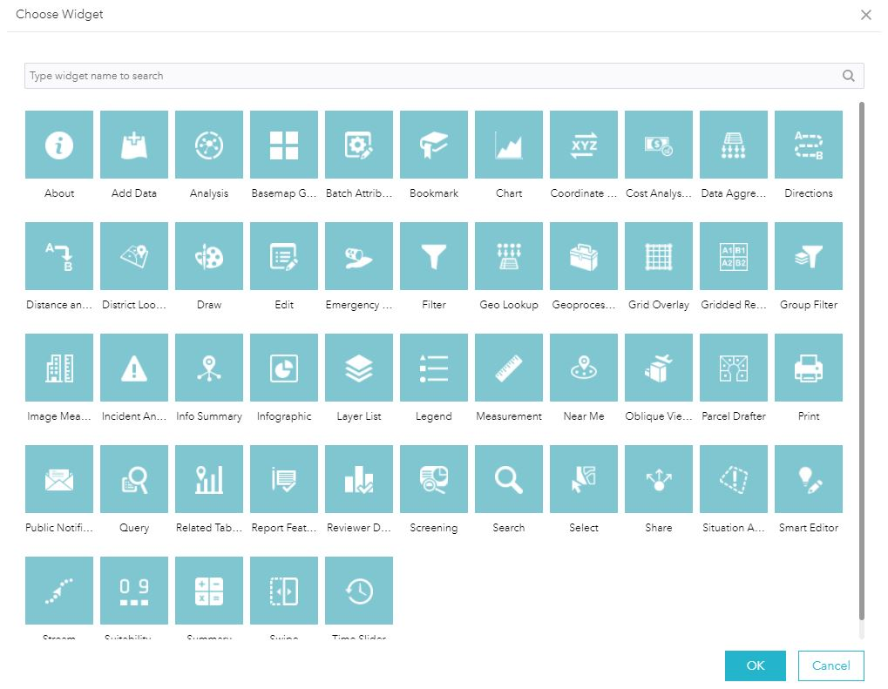

- Explore these widgets and choose 3 Custom Wdigets to add to your map.

- Note that widgets allow you to customize the icon used on the map. You need to have an image on file that you would like to use in its place, and that image is small (24 x 24 pixels recommended).

- What three widgets did you choose? How do each of them add value to your map & application?

- Now, let’s add some widgets in the header or sidebar. At the top of the widgets window, you have an option to specify the widgets that appear in the header or sidebar. If you do not have this option, you need to pick a different theme.

- Click Set the widgets in this controller.

- Click the plus button and add the Print widget. Click the pencil to see the options for configuring the widget. You can accept the defaults, but note that the service URL may need to change depending on whether data layers on your map are shared globally or internally to your organization.

- Click the print button to see how it works. Open the pdf to see the map document the widget creates.

- Now, let’s add a widget that is data dependent. Click in one of the Custom Widget boxes and choose Charts. For the Data source, choose BensonBubblers. You will create a pie chart of the different categories of Bubblers.

- Name the chart Benson Bubbler Types. For Chart Display, select Display feature counts by category. For the Category Field, select PopupInfo. For Chart Type, select Pie Chart. Modify the selection symbol and highlight color if you want.

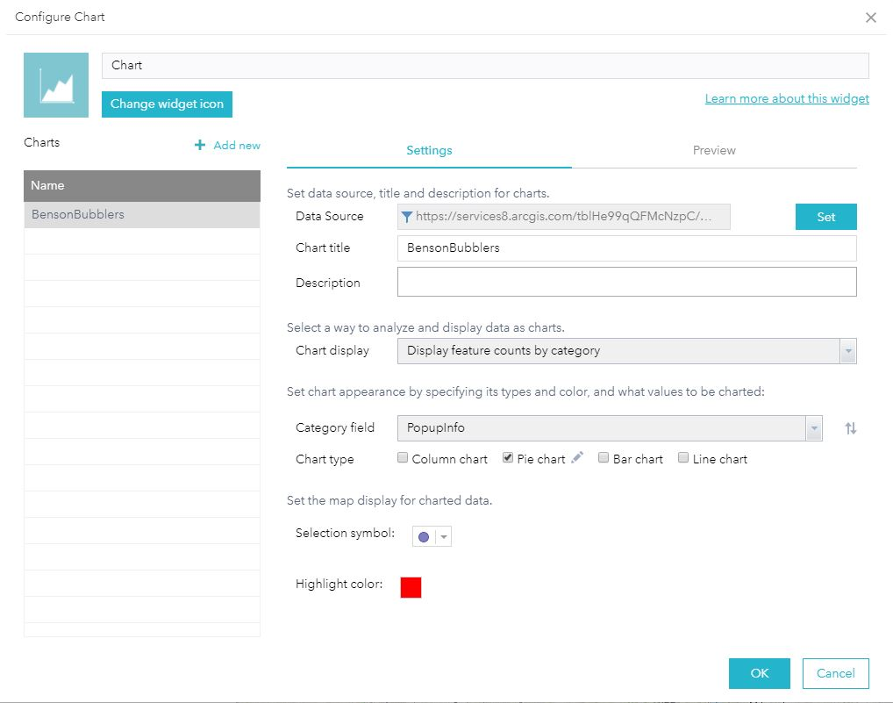

- Click OK, then check out how the chart button works. The Spatial Filter allows you to look at data in the current map extent or to draw a shape to define an area to explore. After you click Apply, you should see your pie chart. It doesn’t look pretty! At this point, you might realize that your attribute table needs some work to make this chart effective. If you hover over the pie segments, you get a more readable pop-up.

- Explore on additional data dependent widget (query would be an example of one), configure it, and add it to your map.

- What data-dependent widget did you choose? Explain how it works with this data. Did you work as you expected?

- Now – let’s preview the map. At the bottom of the Design window, click on Preview. Check out what your app looks like on multiple mobile devices.

- Click on the Launch tab to see what it will look like outside the Web AppBuilder window.

Finalizing your map for submission
At the end of this lab, you should have an app that has:
- A base map with 3 data layers (all related to Benson Bubblers)
- A specific theme, layout, and style plus appropriate attributes for the header.
- Configured default widgets for your theme – remember to configure widgets that may be in your header or sidebar, such as the legend and layer list.
- 3 custom data independent widgets
- A print widget in the header
- A chart widget
- One additional data dependent widget

Sharing your App
- Under My Content, click on your app, then click on the Share tab and share with the Interactive Map Design 2018 group.

