Lab 4. A little more with ArcGIS Online (AGOL)
In the previous lab you were introduced to the basics of ArcGIS online. You created an account, creating a new map, added various types of data to the map and started to share it with the group. This lab will focus on building on those skills and demonstrate some additional features and functionality of ArcGIS online.

Instructions.
Following the instructions below to become familiar with the basic functionalities of AGOL. Answer any questions in bold and follow instructions for lab submission.

Part I | Additional functionality of AGOL

Additional options for sharing your map
Your web map cannot be viewed by others until you share it. In the previous lab, you learned the basic methods of sharing a map with others. There are options that allow us to control who the web map is shared with and what methods may be used to share it.

In AGOL, maps can be shared with everyone, your organization, or confined to selected groups. In the previous lab, you shared your map with the class group. Only members of this group will be able to access your map. Even if someone has the URL, if they are not a member of the group, they will not be able to view the map. This is great if you want the map to remain private, but there will also be time that you want to make it accessible to a wider audience.

- Open the web map you created in Lab 3. Click the Share button so the pop-up box opens.

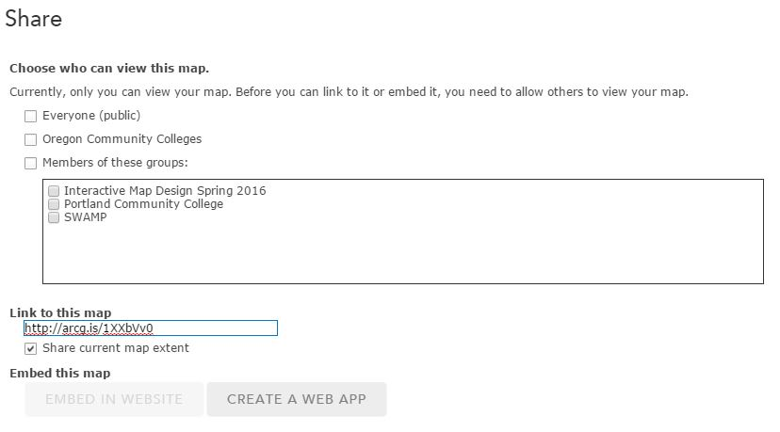

- You can check the 2nd box if you want to share it with everyone in the Oregon Community Colleges organization. Only members of the organization would be able to view the map with the URL.

- Now, check the Everyone(public) check box. This will make your map viewable to ANYONE with the URL.

- There are a few more ways of sharing your map with others – you may have noticed that when you check the different options for sharing, grayed-out options at the bottom of the pop-up become active (i.e. Embed Map). Public maps (those shared with everyone) may be shared with the URL, via Facebook or Twitter, by embedding the map in a website, or by making a web application.

- Make sure the Everyone(public) box is checked. When the Embed Map is active, click on it and it will bring you to the following screen:

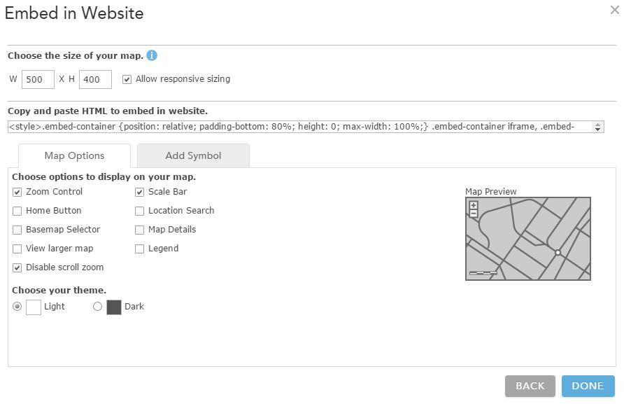
- There are a few options you can set – go through and arrange your map according to your preferences and then copy the HTML code provided. Open up the AGOLmap.htm document using Notepad. Paste the code into the body of the page. Customize the title and the map description and save. Then open the htm doc in a web browser and you should see your map!

- You can also check your Shared settings through your My Content page. If you click on a map in that list, it will bring you to the map’s metadata page. You should see an icon ‘Share’ that will allow you to change who the map is shared with.
Publishing your map to an application.
AGOL offers a suite of configurable apps that can help bring your stories your life. For most of the apps, once you have the map created, the majority of your work is complete. Choosing an app has some built in functionality that will make your map more useful to your users. To find out more about specific functionality in the configurable apps go here: http://doc.arcgis.com/en/arcgis-online/create-maps/choose-configurable-app.htm

- You will need to be in your Map at this point, and click on the Share button. Click on Create a Web App. A pop-up window will appear that shows you all the available web application templates.

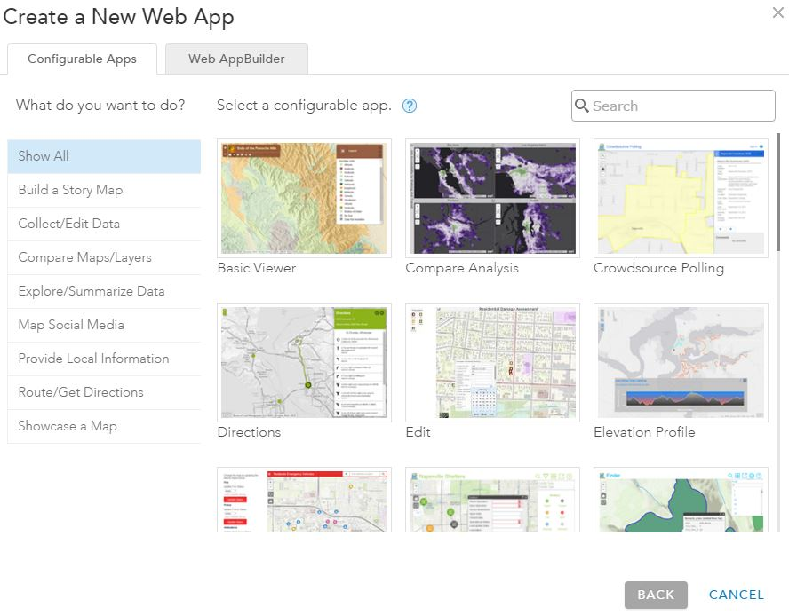

- Take some time exploring the different options for web applications. After spending some time exploring, select the Basic Viewer. A new screen pops up with three options – preview, download, and Create App. Preview allows you to see the map before publishing it. Download allows you to download the application’s code so that you can modify it. And Create App will publish you map with that application.

- First – let’s preview the map. Go through and select other app types and preview those.

- What does the Map application provide for your map? After exploring a couple – what is one app template that you could see being useful for an interactive map?

- Click Create App. Fill out the title, tags, and summary and click Done.

- The next screen that pops up allows you to customize the various components of the app (General, Theme, Tools, Search, Custom URL Parameters). Go through and create some custom options to your web app.

- What is a splash screen? What is one other option in the configuration that you find interesting?

- You can always go back and configure your app differently if you do not like the way it turns out. Go to the map Metadata page and you will see a button for Configure App.

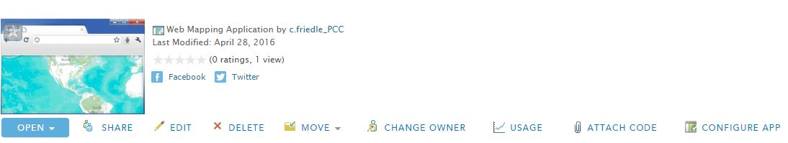

- Open up your HTML script again in Notepad and replace the map, with the embed code for the Map application. Open it up in a web browser to make sure it is working correctly. Save as Yourlastname_BasicApp.htm and turn in the .htm doc as part of your lab.

- Now, I want you to create another Web App (from the same map) of your choice. You can use any of the templates except for Basic Viewer, or use the Web AppBuilder to build one from ‘scratch’.

- What is the purpose of your custom web app? What consdierations did you make while designing this app?

- Create another .htm doc with the embed code for your 2nd app. Save it as YourLastName_CustomApp.htm and turn in the doc as part of your lab.

Editing geospatial data.
AGOL allows the ability to edit some types of data layers. It is possible to create Hosted Feature Layers – these are layers that are stored in the cloud on the ArcGIS online server. This is one advantage to web mapping – it allows you to collaborate with others, and add or update your data.

You have already explore some data types you can upload and add to your maps, such as shapefiles and GPS. You can also create data layers from spreadsheet data in .csv format. The spreadsheet should have columns containing coordinate data in order to place the locations of features.

For this next section, you will first create a hosted feature service by uploading your spreadsheet, then you will add it to your web map, enable editing, and perform a few edits.

- In AGOL, go to My Content to open up your content page. At the top of the Contents list, click the Add Item link and add from your computer.

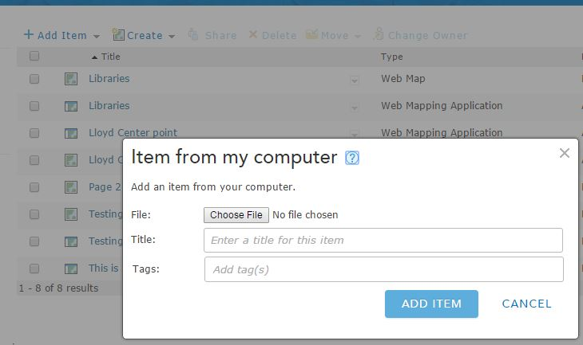

- Go to Choose File and select the BensonBubblers.csv from the Lab5data folder.

- Change the title to Benson Bubblers, and add a few tags. Click Add Item.

- A new Item from my computer window will appear. Make sure that the ‘Publish this file as a feature service’ is checked. And set your Location fields as shown below.

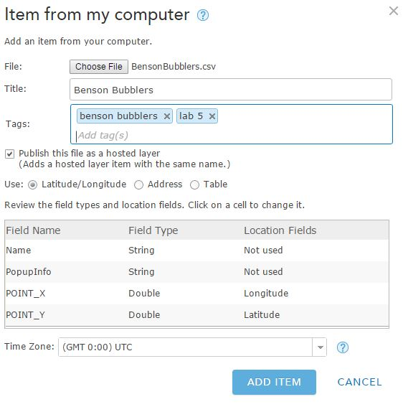

- Click Add Item. The feature service will be created. It should now appear on your My Content page. By default, it will not be shared so others will not be able to see or edit it.

- Locate the layer on your My Content page and click the title. The layer’s property page will display. Click the Share link and the Share window will appear.

- Share the layer with the Interactive Map Design 2017 group.

- Go to Edit, and make sure that you have enabled the Editing features (Editors can add, update, and delete features).

- Go back to your original map for this lab (not the application, but the map itself). Add this new layer to your map. You can click on the Add button>Search for Layers>My Content. When you find it, click on it and then click on ‘Done adding Layers’.

- The Benson Bubblers should now be in your map. First, we are going to change the symbols – your choice – change the symbols to something appropriate for your map.

- In order to start editing the Benson Bubbler information, click on the Edit button on the top menu. Zoom into one of the bubblers and click on the feature. The feature’s attributes will appear in a popup.

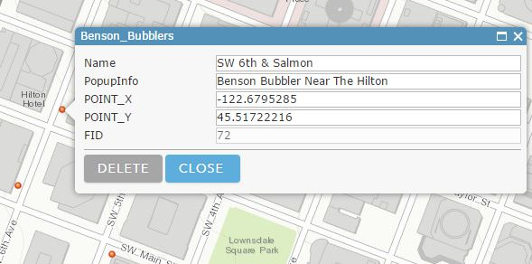

- You can edit the attributes by typing them in the appropriate fields. Change the Name & pop-up info to whatever you choose.

- Note: editing the latitude & longitude values will NOT change the location of the feature. To move the feature you can drag it with your mouse.

- If you need to delete a feature, click on Delete. Click Close when you are all done making your edits.

- When in an editing session, you can also add new features (the Add features window should have appeared when you first clicked on Edit). Each layer has its’ own features that can be added. Scroll down in the Add features window until you find the Benson Bubblers.

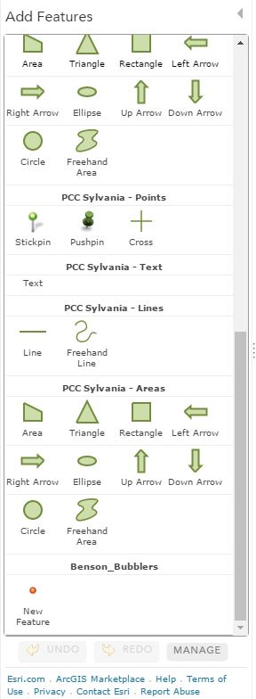

- Click on the New Feature for the Benson Bubblers and then click on your map to add a new feature. The attribute pop-up will appear when you add the new feature. Be sure to populate these values (you can leave lat & long blank). When you are finished, click Close. Add a couple of more points, filling in the attributes and then save your map.

- Take a screen shot of your newly created features and add it into your lab doc.

Analyzing data with AGOL.
In addition to using AGOL to create and publish maps, you can also run a number of analytical tools on your map data. There are quite a few tools available, but for this lab we will create buffers around your newly-created Benson Bubblers layer.

- Before we create the buffers, click on the Analysis button and spend some time looking through the geoprocessing tools that are available. **NOTE** DO NOT run these tools. Each time you run a tool it takes ‘credits’ from our account.

- Are there any tools that you are unfamiliar with from ArcGIS desktop?

- Pick two tools and explain what you could do with them (click on the little ‘i’ icon next to each tool). Does it seem easier to more difficult than working with tools in the Desktop version?

- In the Perform Analysis window, click on Use Proximity to show the tools available.

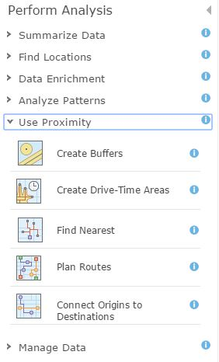

- Click on Create Buffers to open that tool. We are going to create a multi-ring 100, 500, 1320 feet from bubblers. Make sure to select the Benson Bubblers layer, put in the three distances (separated by a space), select the dissolve type and rings. Uncheck the ‘use the current map extent’ and click Run Analysis.

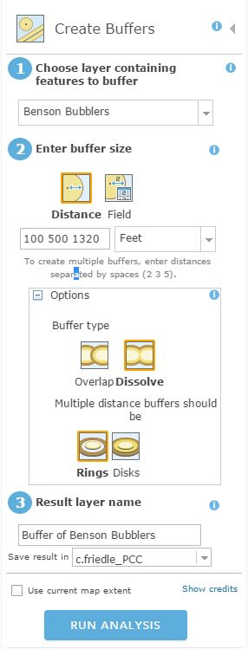

- Are there two or more Benson Bubblers within 100 ft of one another? How can you tell?

- Next, we will create a density of the bubblers so that we can view it as a ‘heat map’. Click on Analysis, and this time go to Analyze patterns. Click on Calculate Density. Select the Benson Bubblers are the layer. There is no count field. Click on Options to see what can be changed. You have the option to make these changes or you can accept the defaults. When finished, click Run Analysis.

- What pattern emerges when looking at the data as a heat map?

- Based on the other data layers you brought into your map – choose one additional analysis to run on one of your other data layers or using more than one layer. PLEASE DO NOT RUN IT MULTIPLE TIMES!!! As I mentioned, this uses credits towards our account.

- What analysis did you run? What were the inputs and parameters that you set?

- Include all your new analysis layers in your map and Save your map.

Finalizing your map for submission.
At the end of this lab, you should have your Lab 3 map & style, with three new analysis layers (also stylized).

- Share the map with the Interactive Map Design 2017 group, and include the URL to your map in your lab doc.

