Lab 4. Story Maps
In the previous labs, you were introduced to ArcGIS online, how to create maps and apps. This lab will focus on building on those skills and learning how to integrate those maps and apps to tell a story through ESRI’s Story Map apps.

Instructions.
Following the instructions below to become familiar with the basic functionalities of Story Map app like Cascade, Journal, or Map Series. Answer any questions in bold and follow instructions for lab submission.

What is a Story Map?
With Story Maps, you can combine your maps with narrative text, images, and multimedia content to create compelling, user-friendly web apps. There are several Story Map application templates you can choose from depending on the story you want to tell. For inspiration, you can find several examples in the Story Maps Gallery.

Part I | Creating Content for your Story Map

You will be creating a Story Map of Portland Bridges using the information from Jim Kettner’s Travel Portland article “Bridges of Portland.” The first thing that you will need to is add a Feature Layer of the 12 bridges.

- Sign in to AGOL and go to your content. You will start by creating a Feature layer of the Portland Bridges (.csv) provided with your lab data.

- Click on ‘Add Item’ and add an item from your computer. Browse to the PortlandBridges.csv. Once this is added a new screen should appear with details about the layer you are adding. Give the layer a name and a few tags. You will want to publish this files as a hosted layer, and use Coordinates (Lat/Long) to locate the features.

z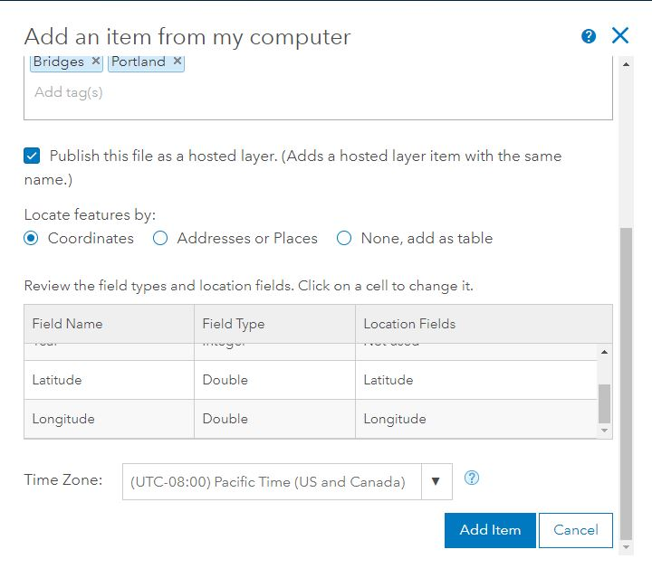

- When you have it all set up, click on Add Item.

- Once the data has been added to your AGOL content, open the layer in a Map Viewer.

- In the Map Viewer, symbolize the Bridges by Name, using Unique Values. Go in and individually symbolize each bridge in a unique style (color, symbol, etc).

Creating a custom pop-up.
- Back in the Contents, click on the (more options) and go to Configure pop-up.

- Make sure that ‘Show Pop-ups’ is checked. Next to the Pop-up title, click on the + and click on {Name}. Delete whatever was in there originally. This will set the Bridge name to appear in the title of the pop-up.

- Choose how to configure the contents. Next to Display: click on each of the different options, go to ‘Configure attributes’ so that you can see what your options are. You must customize this to some degree – how complex you want to make it, is up to you!

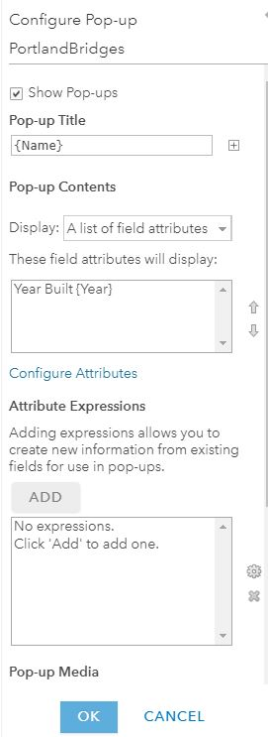

Finalizing your map

- Make any other changes to your map that you wish. For example, change the basemap, create bookmarks, add other layers, etc.

- Save your map.

Comparing Story Map Styles

- Before creating a Story Map of the Portland Bridges, I want you to compare the different style options available. For this assignment, you will pick one of three styles:
  - Story Map Cascade
  - Story Map Series
  - Story Map Journal
- Take some time to explore the Story Map Apps here: https://storymaps.arcgis.com/en/app-list/

- You will find a list of all the apps, which include an Overview, Gallery, Tutorial, and FAQs. For the three app styles listed above (Cascade, Journal, Series), read through the Overview and look at the Gallery of Story Map examples.

- What are the major differences between the three styles? Can you list a couple of advantages and disadvantages of each?

- After reviewing all three, chose a style you would like to use to tell the story of the Portland Bridges.

Part II | Creating the Story Map

- Go back to the Portland Bridges map you created in AGOL. Click on the Share tab. Share your map with the Interactive Map Design group. Click on ‘Create a Web App’ in the same window.

- This time, we are going to use one of the templates. On the left side of the window, Click on ‘Build a Story Map’ and you should see all the App styles to the right.

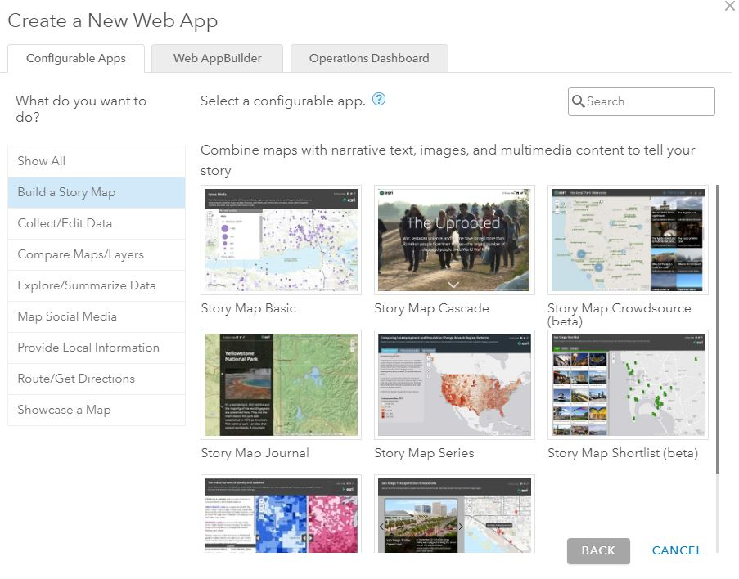

- Hover over your style of choice and click on it. A new window will appear – click on ‘Create Web App’.

- Give the Story Map a Title, tags, and brief summary and Click Done.

- The Web App Builder will open and there will be a wizard that will help guide you through the first few steps. Depending on which style you choose, the wizard will be slightly different.

- Here are the links to the Esri tutorials for each of the Story Map Apps. Take some time to read over the tutorials prior to getting started so that you have a general sense for how things work within whichever style you choose.

  - Cascade: https://storymaps.arcgis.com/en/app-list/cascade/tutorial/, and another good resource: https://libguides.gettysburg.edu/environmentalstudies/es225-s18-project1
  - Journal: https://storymaps.arcgis.com/en/app-list/map-journal/tutorial/
  - Map Series: https://storymaps.arcgis.com/en/app-list/map-series/tutorial/

Story Map Settings

- Each Story Map style will have a ‘Settings’ icon towards the top of the screen. The icon will look something like this or say ‘Settings’. Click on the icon.

- This is where you can modify the appearance of your Story Map. You can add a pic or logo for the title bar, change the color, add a tagline or links, pick fonts, etc.

- Take some time and go through each of the settings to customize your Story App appearance.

Adding Images to a Story Map

- Adding an image to a Story Map can be tricky. It cannot be uploaded from your computer. It has to be an image that can be accessed online through Flickr, Picasa, Unsplash, or directly through a URL. You can search each of these sites or link directly to your account and upload an image from there.

- The important thing to note – if you are linking to a URL – you MUST link directly to an image. How do you know if it is a direct link? It must end with an image extension like .jpg, .png, .tif, etc.

Creating your Story Map

- Using the map you created earlier in the lab, images, videos, other multimedia, and the text from Jim Kettner’s Travel Portland article “Bridges of Portland” (or other sources if you wish), tell a Story about the Portland Bridges!

Finalizing your map for submission
At the end of this lab, you should have a Story Map that has:
- A Cascade, Journal or Series Story Map style
- Information about each of the twelve bridges
- The Portland Bridge map you created in AGOL (with custom pop-ups)
- At least 5 Images or other multimedia included
- A custom ‘appearance’ within the Story Map

Sharing your Story Map
- Make sure that your Story Map is shared with the Interactive Map Design 2018 group or the Organization (and your map too!).

