Lab 5. Mapbox Studio
Mapbox studio is a modern design platform for managing your spatial data and creating custom map styles. You can use it to design a custom map using provided tile sets, uploading your own data, adding custom fonts or images, or to refine the templates provided by Mapbox.

Several years ago, Mapbox developed TileMill, a tool to create raster background tiles and interactive maps. The main advantage of TileMill is that you can style your map with the CSS-like script language called CartoCSS. Mapbox Studio is the new TileMill, with new features and focused more on the vector tile format, which is becoming the modern data type of displaying web maps.

There is a Mapbox Studio manual that you can find here for reference: https://www.mapbox.com/help/studio-manual/. And here you can find tutorials for Mapbox: https://www.mapbox.com/help/tutorials/

Instructions.
Following the instructions below to become familiar with the basic functionalities of Mapbox Studio. Answer any questions in bold and follow instructions for lab submission.

Part I | Getting Started with Mapbox Studio
Mapbox studio is available for free (with limitations on use), although you will need to create an account in order to access it.

- Go to https://www.mapbox.com/studio/signin/ and either sign in (if you already have an account) or create a new account for your personal use.

Once logged in, it will take you to the Home page, where you will see options for Getting Started to create Styles and Tilesets, and explore developer tools or map styles.

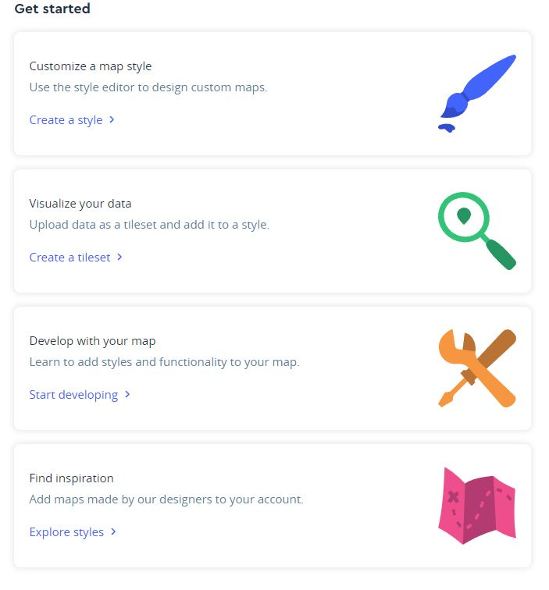
There is also a menu on the top of the webpage that takes you straight to your (already created) styles, tilesets or datasets. Home is your jumping-off point for building maps.

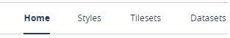

- Home. You can view an overview of your recently created styles, recently uploaded tilesets, and information about your account.
- Styles. Create, manage, and edit your map styles.
- Tilesets. Upload and manage tilesets
- Datasets. Upload, create and manage datasets

You can also check out the details of your account, by going to ‘Account’ at the top of the webpage. This is where you can manage your account billing, security, access tokens and more. Access tokens are similar to Google’s API key – it is a code that you need to use in order to use any of Mapbox’s tools, API’s or SDK’s. Each account has a specified Access Token. You can read more about how they work here: https://www.mapbox.com/help/how-access-tokens-work/

Create a style.
A style is a document that defines the visual appearance of your map. Styles are created in Mapbox studio and uploaded into your account. They include information about data sources, style layers, sprites, glyphs, and metadata.

- On the home page, under Get Started, click on the ‘Create a Style’

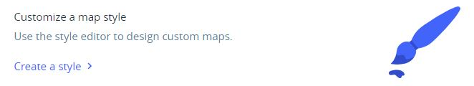

- A new window will pop-up with options to pick a Mapbox template style or start one from scratch.

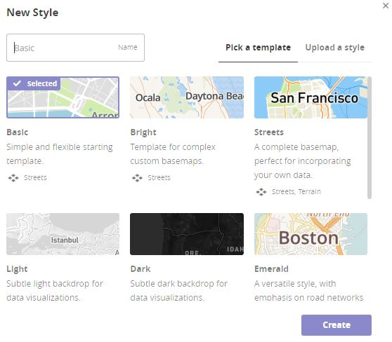
- Let’s start with the basic style and make some adjustments once in the editor. Click on Basic and it should appear ‘selected’. Then click Create.

- A new window will open up that takes you to the Basic Style template. This is where you can do any and all adjustments to Style. If you click on any of the layers that appear on the left-hand side, then you can change the font, color, symbology etc of any layer.

Changing Fonts & Labels

- One of the nice things about Mapbox studio is that you can change multiple properties at once for things like color & fonts. The first thing you will do is upload a new font to use on your map – Lexie Readable – this font was designed with accessibility & legibility in mind (read more about it here: http://www.k-type.com/fonts/lexie-readable/). Make sure to choose the Regular & Bold Free for personal, educational, or charity use. Do not pay for the commercial font! Save the font to a folder on your computer or flash drive (you will have to unzip it first). There is also a copy in your Lab5data folder if you have any issues downloading it.

- You will see that there is another table of contents on the right-hand side of the webpage. On this TOC, you should see Fonts. Click on Fonts, and then click on Upload New Font.

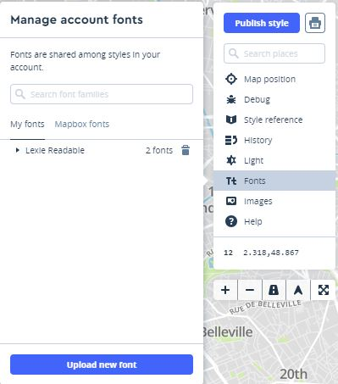

- Click on Select Files and add the Lexie Readable files you downloaded or got in the Lab5 data folder.

- Once the font files have uploaded, you should see them under ‘My Fonts’ and they will now be available to use on your map(s).

- To change the fonts, go the TOC on the left and click on Filter by Value.

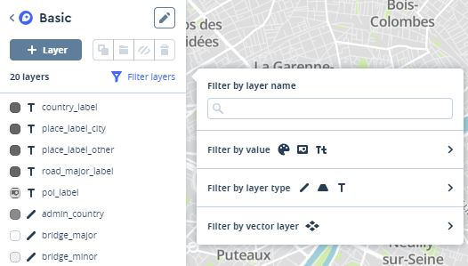
- When the new window appears, click on Fonts. A new window will appear that shows all the fonts on the map. If you click on any of them, it will ‘open’ that layer and will allow you to change the font for that layer. If there are more than one layer with that font type, you can (using CTRL) select all layers and make the change universally.

- Click on both Open Sans Bold and Open Sans Semi-bold. Once the filter has been applied, select all layers in the TOC (using shift or ctrl), then click on Font.

- Set the Font to be Lexie Readable Bold, and the fallback font to be Open Sans Semi-bold. Once you set this, it will be automatically applied.

- Click back on TOC and click on any of the layers you just applied the changes to – you should see that the fonts are now changed. You should also see the changes on your map!

- You can also change the font for any layer individually by clicking on the layer in the TOC and then clicking on Font. This only applies to Label layers!

- Change the font for the Country_label to a font of your choice. Zoom out far enough on the map so that you can see how this changes the look of your map.

- Next, we are going to make the labels higher contrast so that they are easier to see.

- Select the 4 layers you changed to Lexie Readable Bold. Click on Color.

- Click on the Text color (that currently reads #666) and then change it to black by moving the hollow circle around the color window or change the current # to 0a0a0a (black). The color will automatically change on the map as you make changes.

- Now, let’s make a change to just one layer, rather than all layers at once. Click on the country_label under the layers. Again, a new window appears with all the ways that this particular layer can be changed or modified.

- Click on Size. Not only can you change the font size here, but it will show you what zoom level you are currently in on the map and allow you to set sizes at different zoom levels. It will also calculate how the font should scale between the ‘stops’. Bump up the size at zoom level 3 to 16px.

- Feel free to go in and change the labels in any other way you would like – fonts, sizes, colors, zoom, etc. Play around and have fun with it.

- What label changes did you make?

Changing Colors & Textures

- Next, let’s move on to colors and changing them. Click on the Water layer in the TOC and click on Color. Change the color of the water to be darker and higher contrast with the land (your choice).

- Click on the Waterway layer in the TOC and click on Color. This time, under where it says Set Value, click on Value options and click on Pick existing Value. Scroll down until you find the water layer & color you created in the step above. Choose that one to change the waterways to the same color.

- Change the color for Landuse_park as well.

- What RGB or HEX values did you use for the park color?

- The other thing that you can set for color, is the style by zoom level. For the Landuse_park layer, click on Color > Value Options > Set by zoom.

- You can use this to adjust the color at each zoom level or the opacity (transparency). Click on the box that has the color value for zoom level 0 and under the RGB codes, you will see an ‘a’ value, which represents the transparency. For zoom level 0, set that to 40; and for zoom level 22, set it to 20.

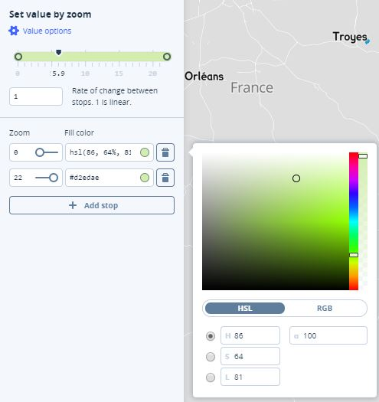

- It is also possible to add texture and patterns into your map. For example, you can create a dashed line for a boundary or line feature. Let’s experiment by changing all major roads into dashed lines. Click on the road_major layer in the TOC and click on Dash Array > Add dash with gap. The dash number is the size of the colored dash, and the gap is the space between your dashes. Experiment by changing the dash & gap by different values and see how that changes your roads layer. Find a dash and gap that you are happy with and set the Major Roads with this symbol.

- Now, change bridge_major and tunnel_major layers to be the same as the road_major (same way you did with colors in the steps above).

- Play around with the setting of all the layers on your base map until you come up with something you are satisfied with. Take your time to look at all options. Have fun with it!

Tilesets & Uploading data into Mapbox.
A Tileset is a collection of raster or vector data broken up into a uniform grid at 22 present zoom levels. Tilesets are used in Mapbox libraries and are a core piece of making maps visible on mobile or web maps. They are highly cacheable and load quickly.

For raster tilesets, TIFFs/GeoTIFFs are valid formats for uploading into Mapbox Studio. Traditional web mapping libraries like Mapbox.js and Leaflet, need raster tiles to display your map on a web page.

Vector tilesets are the same as rasters, except that they store the data as point, lines or polygons. Vector tilesets can be manipulated & queried. To upload vector data, it must be in GeoJSON, shapefile (zipped), KML, or GPX. Once they are uploaded into Mapbox Studio, it is stored in your account and converted into a vector tileset.

In addition to being able to upload and add your own data, Mapbox has a selection of datasets that can also be added to your map – this includes a satellite image (raster) and some additional vector datasets that are not already included on the Basic map style.

You might have noticed that the basic map does not show data at the state or province layer. So, we are going to add that into our base map.

- This is a dataset that Mapbox already has available to add on your Map style. Click on + Layer in the layers TOC.

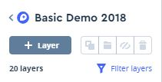

- A new window will appear – Under source, click on ‘No tileset, click to select’ and a list of available tilesets will appear in another window.

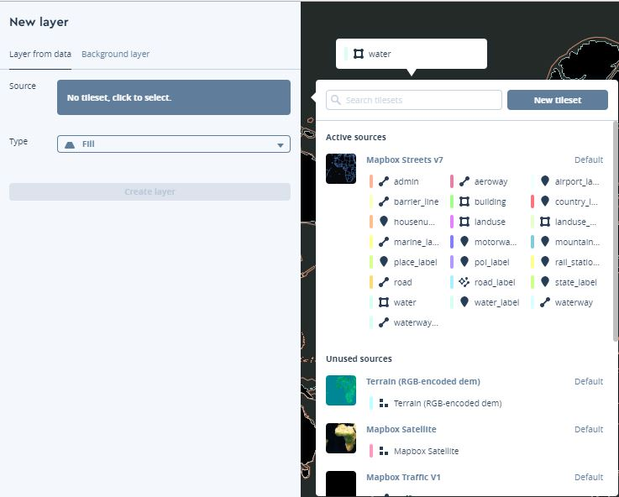

- This list allows you to see all the available data sets through Mapbox – there are terrain options, satellite images, and any data layers that you have uploaded into your Mapbox account.

- Click on Admin – this is the layer that includes states & provinces.

- Change the min zoom level to 3 so that they don’t appear until you zoom into the map a bit.

- Assuming that we are going to use this map for just the US, let’s use the Filter to only show the state boundaries in the US. Click on Add Filter and when the Available Fields window appears, click on iso_3166_1. Write the ‘query’ so that it reads, is any of ‘US’.

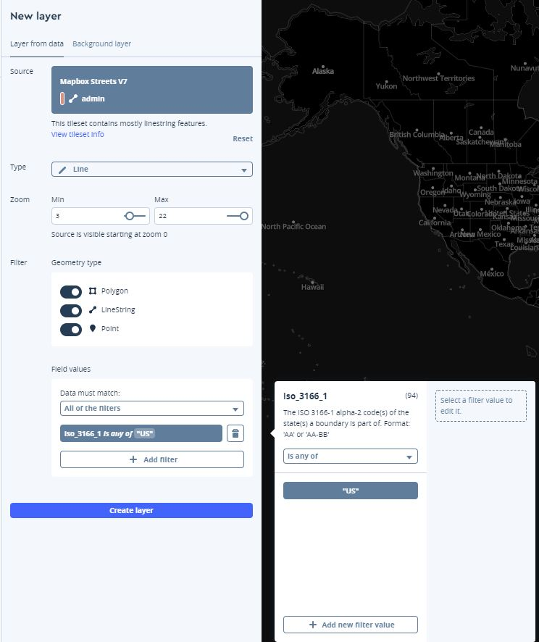

- Now, let’s add another filter to get rid of the ‘maritime’ border that shows the territory of states into the ocean. Add another Filter, where ‘Maritime is any of 0’

- When both filters are set, click on Create Layer.

- Click on the new layer in the layers window and change the style (color, width, etc) so that it fits with the rest of your map.

- You can also upload a data set; this can be done by either adding a tileset directly into your Map Style or you can go back to your homepage and upload through your Datasets or Tilesets.

- Find a data set – this can be the bike crashes that we used in a previous lab, a dataset that you have created for a project, or a dataset that you want to find from RLIS, Civic Apps, or any other source – your choice! Let’s add this dataset to your map.

- To add it directly into your map style, follow the steps above and when you go to select a tileset, click on the New Tileset on the top of the window.

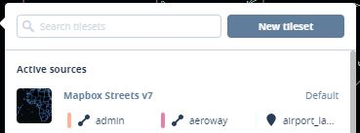

- Alternately – you can go to your Tileset page and upload by clicking on New Tileset and following the prompts. If you add it using this method, you will still need to go back to your Map Style and add the tileset to your actual Map.

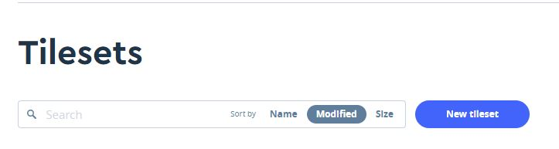

- Make sure that you style the new tileset after adding to your map style.

- What dataset did you add? Did you add a filter? How is it styled?

- When you are all done, click on Publish Style on the TOC on the right-hand side of the page.
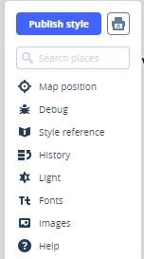

- A new window appears that allows you to see the differences between the map before your changes (the last time you saved/published it) and after. Click on Publish.

- You should see a screen that says “Congratulations!” Click on Share, develop and use your style. If the map preview on the next screen appears blank, reload the page.

- In the Share section, copy the Share URL and add it to your map document. This is how you can share the map you just created.

Making a choropleth map using Mapbox Studio.
Who doesn’t love a choropleth map? It’s an easy-to-digest map that shows areas shaded in a graduated color scheme based on a particular value.

- In your lab5data folder, you will find a GeoJSON dataset of population density across the US (grabbed from the Mapbox studio tutorial).

- First, we will need to upload this file into your tilesets. Go to your Tileset page, click on New Tileset and upload the stateData.geojson file.

- When the upload is complete, click on the filename in your list of Tilesets to open up its information page. This page allows you to see the properties of the data including, attributes (density & name), Map ID, format, size, geographic bounds, and zoom extent.

- Once the data is upload and you had a chance to review it, go back to your Styles page and create a new Map Style for your data. This time, use the ‘Light’ or ‘Dark’ (your choice) style and click Create.

- Next, we will add our Population density data. Click on +New Layer and walk through the same steps as in the previous section to add the stateData.geoJSON file to your Map style (no filters).

- When the Layer has been added to the map, it will probably be added as a default color & transparency. We want to change this so that we can see the data based on the population density. In order to do this, you will set the color value by data values.

- Click on the new layer in the TOC > Color > Value options > Set value by data.

- Set the Field to Density. Keep the Domain as a number and set the Function type to Interval since you will be assigning colors to each state based on specified intervals. Set the default value to #800026.

- Now it’s time to start adding ‘stops’ and colors. You’ll create several stops to break states up into group with similar population densities. Click Add Stop to add new stops to the list.

- Create the following stops:
  - 10: #FFEDA0
  - 20: #FED976
  - 50: #FEB24C
  - 100: #FD8D3C
  - 200: #FC4E2A
  - 500: #E31A1C
  - 1000: #BD0026

- As you start adding stops, you should see the map change on the right to reflect the new stops. In this case, all states with a population density between 0-10 will be assigned the color #FFEDA0, all states with population density from 10-20 will be assigned the color #FED976, and so on. Any states with a population density outside the set intervals (in this case, over 1000) will be assigned the default value, #800026.

- Change the 1px Stroke color to white or something close to it.

- Move the Population Density layer you created below all the label layers in the TOC (pick up and drag it) so that the labels are visible.

- Let’s get rid of all the place name labels – or at least shut them off for this map. Select all the Place labels and shut the group layer off by selecting Hide layers icon. 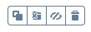

- Move the water layer above the Population Density group.

- Lastly, publish your map!

- Copy & paste the Share URL and add it into your lab doc.

Extra Credit! Adding Interactivity to your Choropleth map.
For those of you wanting to learn more about Mapbox and its capabilities, follow this tutorial on how to the use the Mapbox GL JS to add some additional features & interactivity to your map.

If you choose to complete this – include the text doc of your html and map code with your lab submission.

Here is the link to the tutorial: https://www.mapbox.com/help/choropleth-studio-gl-pt-2/

